Adapting Washington’s Hydropower for Climate Change:
Creating a Plan to Handle the Future
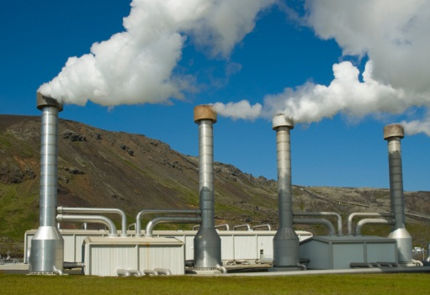
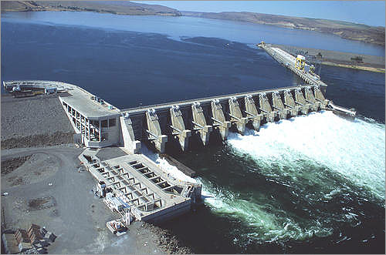
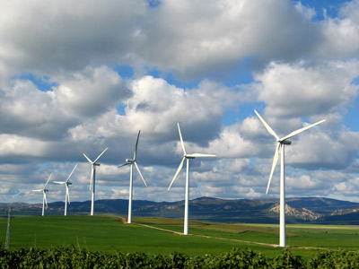
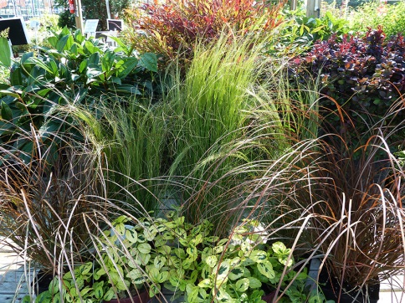

By Caitlin Budd, Claire Mueller, and Tim Calderwood
CEP 302
Julia Michalak
Due date: 3.7.2012
Introduction:
The Columbia River Basin's sources of water are very sensitive to climate change. Currently, the Columbia River Basin is a snowmelt dominant watershed, meaning that it is dependent upon snowpack for much of its water supply. Climate change is projected to cause more winter precipitation to fall as rain rather than snow, which will lead to earlier snowmelt, higher winter streamflows, and lower summer streamflows (Elsner et al, 2010). Without adapting to these changes in climate, water supplies in Seattle, Tacoma, and Everett are expected to decrease substantially (Binder, 2009). Also, hydropower production, the main source of Washington's energy, will decrease in the summer when energy demand is expected to increase due to rising temperatures (Markoff et al. 2007). Operational changes and different approaches to energy planning will be necessary for responding to streamflow timing shifts.
Increasing population and rising temperatures are expected to cause energy demand for heating and cooling is expected to increase (Markoff et al. 2007). Demand for energy for cooling is expected to increase significantly more than energy for heating, 363-555% by the 2040s relative to the late 20th century compared to 35-42% by the 2040s for energy used for heating. Unfortunately, regional hydropower supply is expected to change inversely to energy demand, increasing in the winter and decreasing in the summer, which will exacerbate projected growth in cooling energy demand (Hamlet et al. 2010). Adapting to changes in energy supplied by hydropower will be essential, especially in the summer. Resources will need to be allocated between increasing hydropower generation capacity for summer energy production, decreasing demand for electricity, and implementing other renewable energy sources (Binder, 2009).
Other non-climatic factors can intensify projected changes in Columbia River Basin hydrology. Examples include development of communities in flood plains, and loss of riparian habitat, which in addition to other non-climatic factors, can intensate low streamflow, warmer summer water temperature, and winter high flows that damage surrounding property. Population growth and energy policies that emphasize use of hydropower as a renewable energy source also add stress to Columbia River Basin water system (Binder, 2009).
The impacts of climate change on the Columbia River Basin hydropower production require new approaches to water management, and increased flexibility in conservation and management of water resources (Hamlet et al. 2010). Strategies for adapting to these changes in climate include expanding and diversifying water supplies, developing new or alternate water supplies, improving efficiency, reducing demand, relying on alternate forms of energy during summer months, implementing operational changes, and changing water transfer between users and uses (Binder 2009). Most of these adaptation strategies are just extensions of existing water planning and management strategies, but even these extensions are critical to adapting hydropower production to projected changes in climate.

Assessment of the Risk and Vulnerability from Climate Change to the Columbia River Basin:
The Columbia River Basin is a vast watershed system which supplies the Pacific Northwest with hydroelectricity, drinking water, irrigation for farming, and is a valuable ecological habitat for salmon. Qualitative risk assessment is one way of defining what risks are most likely to occur and what the consequence will be. The assessment of risk is usually considered using the “equation” likelihood of occurrence times the consequence if it occurs. Vulnerability is the potential for a system to be harmed by outside sources, such as climate change. Doing tests to understand the risks and vulnerabilities in a system allows scientists and planners to prioritize based on projected and observed impacts. Planners need to consider: magnitude, timing, persistence/reversibility, likelihood/certainty, importance, and equity in the Columbia River Basin.
Hydroelectricity is the world’s first truly renewable resource (CCRH, 2005); however, it only lasts as long as stream flow maintains a minimum rate. Using a Risk Assessment that takes climate change into account, scientists predict that this will be the most vulnerable part of power production in Washington State (Binder, 2009). Washington needs to explore how that change will affect hydroelectric power production to mitigate the most likely negative impacts on power production.
There are many factors that affect stream flow and, thus, a dam’s ability to produce power. They include ecological issues (salmon habitat), economic issues (ability to transport goods), and snow melt (decides the timing of floods and high flows). The most pressing of these issues is the timing of snow runoff. With climate change, the timing of runoff is expected to change because snow will melt earlier in the year and more precipitation will fall as rain. Currently, snowmelt in the spring and early summer, in addition to water stored in dam reservoirs, provides enough stream flow to sustain hydropower production through the drier summer months. With the coming climate change, snow will no longer be able to power the dams through the dry summer months, meaning that hydropower production from June–September is the most vulnerable to climate change . With low summer flows, there is concern that ships and barges will no longer be able to transport goods as they have previously. This would badly damage the economy of the Columbia River Basin, which produces a large portion of Washington State’s agriculture. Additionally a consequence of climate change is the warming of the waters of the Columbia River Basin which is not good for salmon habitat. Salmon have long been seen as an important part of Pacific Northwest (PNW) culture, but if stream flow is not maintained in the summer, they will no longer be able to spawn in the high reaches of the Columbia River. Thus the economy of the fishing industry and the PNW cultural attachment to salmon are both at high risk unless stream flow and high water temperature in the summer is mitigated. (Markoff et al. 2007)

Identifying multiple strategies:
There are many adaptation strategies available to prepare for the projected effects of climate change. Determining viable options that directly address the problem can be difficult. Strategies cover a wide range of possible actions that increase adaptive capacity, which include decreasing power use on a consumer level, expanding renewable energy supply by implementing alternative methods of power production, changing water management policies, connecting regional water supplies, or purchasing power from states such as California or Oregon (Binder, 2009).
Development of new or alternate water supplies is one adapatation strategy that could be implemented in the Columbia River Basin. This strategy would entail developing new sustainable groundwater resources, constructing new surface water reservoirs, developing advanced wastewater treatment capacity for water reuse, implementation of new technologies such as reverse osmosis for desalination in coastal areas, and encouraging rainwater harvesting to provide water supply for residential and commercial buildings (Binder, 2009). Implementation of this strategy would increase the adaptive capacity of built and human systems. Also, it would lead to much more efficient use of water as well as provide new water sources, which would decrease reliance on water from the Columbia River Basin. Higher flows and more water available for hydropower production would result. However, many of these actions, with the exception of encouraging rainwater harvesting, would take considerable time to implement because they require changing or building new infrastructure.
Another adaptation strategy is implementation of operational changes. Actions involved in this strategy include rebalancing flood control rule curves and reservoir refill schedules, allocating increased storage for instream flow, improving hydrologic forecasting and use of forecasts, increasing use of optimization in reservoir management to rebalance systems, shifting hydropower generation schedules to emphasize summer energy production, revising maintenance schedules to conserve water, and using existing flood irrigation systems to recharge soil moisture and groundwater during winter (Binder, 2009). Because this strategy involves adapting systems already in place to the expected outcomes of climate change, the implementation time frame is short relative to adpatation strategies that require large initial investments for example. Actions taken throughout the Columbia River Basin will not be uniform because some areas will experience changes that other areas do not and so on – optimization, shifting hydropower generation schedules, and flood control will all have to be dealt with on a regional level depending on how specific regions will be affected by climate change.
Boosting energy supply is another strategy that can be accomplished by increasing the capacity of conventional energy supplies, increasing the local transmission capacity and peaking generation capacity, and transferring excess winter energy capacity in California and the Southwest, areas in which warming is expected to lead to excess capacity, to the Columbia River Basin (Binder, 2009). Increasing the local transmission capacity and peaking generation capacity would prepare energy distribution systems for the projected increases in peak loads in summer. So, this adaptation strategy increases the adaptive capacity of built systems in addition to easing the challenges presented by meeting summer energy demand.
Agricultural water supply and use can also be modified to increase adaptive capacity. Actions included in this strategy include promoting new irrigation techniques that improve water use efficiency, promoting water conservation, using market forces to distribute water, and diversifying and expanding water supplies and infrastructure (Binder, 2009). These actions have different implementation time periods. Promotion of water conservation and new irrigation techniques can be accomplished in a short time because it does not entail change so much as eduction, whereas expanding infrastructure requires major investment and thus require more time for implementation. For example, expanding irrigation techniques to include drip irrigation requires paying for and installing a whole new irrigation system. By decreasing agricultural use of water, pressure on the Columbia River Basin water supply would be alleviated slightly and thus more water would be available for hydropower production.
An adaptation strategy that mitigates negative environmental of actions beneficial to hydropower production is reducing summer stream temperatures and protecting minimum instream flows during summer. This strategy involves reduction of out-of-stream withdrawals during high temperature – low streamflow periods, restoration of riparian zones, and modification of reservoir operating rules to mitigate summer low flow and water temperature impacts (Binder, 2009). Restoration of riparian zones decreases stream temperature, which is beneficial to salmon. Modifying reservoir operating rules to avoid extreme summer low flows and increases in water temperature is beneficial to both hydropower produciton and salmon (NW Council, 2012).

Increasing Water Storage Capacity:
The first step in adapting water supplies should be a comprehensive assessment of both groundwater resources and surface water storage capacity. Although surface water storage alone is easier to calculate, including both surface and groundwater provides a more accurate estimate of current storage capacity. From there, it is easier to determine how much water storage capacity needs to increase through adaptation planning. Increasing water storage capacity is a key component of any comprehensive water management strategy/adaptation plan. However, water storage modifications are large projects that require major investment and are potentially harmful to the environment. It is important for Washington state to begin looking at increasing water storage capacity now by evaluating sites for new reservoirs and by evaluating which aquifers, dams, and reservoirs are candidates for modification. These modifications will benefit many stakeholders and, even though state budgets are tight, investing in this key component of adaptation now will significantly improve the state's ability to compete economically when water supplies decline (Working Lands and Waters Topic Advisory Group, 2011).
Aquifer Storage and Recovery
Expanding and diversifying existing water supplies is one way to ease the impacts of climate change on hydropower production. There are multiple possible actions within this adaptation strategy including enhancing existing groundwater supplies through aquifer storage and recovery, and adding capacity to existing reservoirs by raising dam height, as identified by the Washington Climate Change Impacts Assessment (Binder, 2009).
Aquifer storage and recovery involves injecting water into aquifers through surface spreading, infiltration pits and basins, and/or injection wells to recharge the aquifer during times when water is readily available (Working Lands and Waters Topic Advisory Group, 2011). This water then gets pumped out when it is needed, so the aquifer acts as a water bank – water gets deposited during times of excess water availability so that water can be withdrawn during times of water scarcity. Aquifer storage and recovery expands aquifer function previously limited by low water levels due to excess pumping in response to increasing urban and agricultural water demands. Significant amounts of water can be stored deep underground using this technique, which reduces the need for more expensive and land-intensive surface reservoirs. Also, aquifer storage and recovery systems are more environmentally friendly and are less likely to be tampered with than surface reservoirs (Access Washington, 2012).
This adaptation strategy would increase the capacity of a built systems that provides an essential function, water storage. There are costs and benefits to aquifer storage and recovery. Some of the drawbacks are a slow water recharge rate, potential for groundwater contamination, a cost to retrieving the water, and water not being recoverable from aquifers in its entirety. Advantages include little loss to evaporation, quick availability, more water stored for irrigation, less competition over water access, and water quality. Also, underground aquifers, unlike surface reservoirs, are not at risk of flooding (Binder, 2009). This is a low regrets adaptation because it does not have a high initial cost and because it does not negatively effect major stakeholders like some other water storage options. Also, because water availability in the summer is expected to decrease in nearly all climate scenarios (Elsner, 2010), using aquifers as a reliable water source is a robust adaptation strategy. Aquifer storage and recovery offers flexibility to adaptation plans. This is because the aquifers are already in place, it is just a matter of investing in the technology required for injecting water back into the aquifers and for then recovering that water when it is needed.
There is great potential for aquifer storage and recovery in Washington state, but more resources and authorities would need to be dedicated before it could be implemented, making it a tier 2 action. It is estimated that aquifers underlay 60 percent of Washington and are capable of yielding at least 50 gallons/minute. About 50 percent of these aquifers may be suitable for aquifer storage and recovery (Working Lands and Waters Topic Advisory Group, 2011).
Adding Capacity to Reservoirs
Adding capacity to existing reservoirs by increasing dam height is a more resource intensive adaptation strategy than aquifer storage and recovery. The structures required for action are already in place for aquifers, whereas increasing reservoir capacity entails more building/adding to existing structures. The costs of increasing dam height include the large initial investment required, and the negative environmental impacts. Reservoirs cause slower water flow, which leads to higher water temperatures. This threatens salmon habitat because salmon have an ideal temperature threshold and avoid water with temperatures that exceed this threshold. Another negative environmental impact associated with reservoirs is change in sediment transport, which alters the flow of rivers (NW council). Further flooding of riverside lands is another potential negative impact. This would affect lowland farmers and communities living in flood plains, in addition to destroying riparian habitats that shade and cool the river (Pace Energy and Climate Center, 2000). However, there are also some definite benefits to this strategy. Larger reservoirs provide substantial, reliable yields and have low cost per volume stored. The stored water can be used for hydropower generation and also for controlling floods downstream. Seepage from large reservoirs also contributes to groundwater recharge. Another benefit of raising dam height is that it is robust for almost all climate emissions scenarios and global climate model combinations, which generally predict more winter precipitation falling as rain and earlier snow melt. Increasing reservoir capacity would allow greater storage of winter precipitation for use in the summer months when energy demand is expected to increase (Markoff et al. 2007).
Although this action is robust under almost all climate predictions for the Columbia River Basin, it is not very flexible because once new dam infrastructure is in place, it is very costly and time-intensive to remove. The cost of implementing this action is already very high, so it is important that thorough planning proceeds action as to avoid having to pay for removal costs as well. High initial costs, need for thorough planning, low flexibility, and negative environmental impacts puts this adaptation action in the long term implementation strategy. The state or even federal government needs to allocate a significant amount of money to this project, which would involve much deliberation, making this a tier 2 action.
Alternative Forms of Electricity Production:
As hydropower production becomes more difficult due to dropping summer water levels, Washington State needs develop alternate forms of energy to keep this state powered through the summer. Although it is true that electricity can be purchased from California and Oregon, this process is complex and expensive, in addition to being very vulnerable to outside forces (IPCC, 2007). To handle the coming power shortages, Washington State should begin to invest in alternative sources of energy so that in 50 years, this State does not face an energy crisis which would cripple the economy and damage the Washington standard of living. There are many forms of alternative electricity available, and in this section, the pros and cons will be laid out and addressed to determine what alternative form of power is most feasible for Washington.
The 3 most viable forms of renewable energy are nuclear, wind power, and geothermal. One may wonder why solar is not on this list as it is a truly renewable energy source, but at this latitude, solar power is very inefficient. The radiation that solar cells absorb are not intense enough to provide a worthwhile investment. All of these are considered renewable because their power will not decrease over time and they are not dependent on the input of coal, water, or any other natural resource. The risks for each one very greatly, and are perhaps the most deciding factor as to the ability of implementation in this state.
Nuclear Power
Nuclear power has gotten a lot of media attention lately due to the impact of a tsunami on Japan’s nuclear power plants. The power plants there were damaged by a tsunami and earthquake, making many Japanese citizens concerned about a meltdown or leaking nuclear fluids (New York Times, 2011). Japan was previously the country with the most nuclear power plants in the world, and has long been a supporter of nuclear power (New York Times, 2011). After the tsunami hit, Japan announced that it will discontinue its nuclear program, which increased public concerns about the safety of this form of energy (New York Times, 2011). In Washington’s own Hanford, there is a nuclear power plant which has been a source of controversy for decades, because the nuclear waste there is leaking into the Columbia River Basin, despite ongoing attempts to contain it (Dininny, 2010).
Washington State is perched on the brink of the Pacific Rim, and sits on the edge of the North American Plate where it meets the Juan de Fucan Plate (USGS, 2007). These two plates are active, and seismologists have been predicting a major earthquake in Washington State for more than 10 years (USGS, 2007). In Japan, the major problem with their nuclear reactors was that the tsunami damaged the containment of the nuclear waste in their plants, which in turn can cause major human and environmental health issues (New York Times, 2011). The country now needs to dispose of hugely toxic waste, but scientists have been unable to find a lasting solution to the problem of nuclear waste (New York Times, 2011). For this reason, it seems that nuclear power is not a good option for Washington State. This state takes pride in its air and water quality, and is known for major earthquakes. Installing a power plant that is known to be vulnerable to natural disasters and causes major health issues does not seem like a good fit in this region.
Wind Power
Wind Power is a form of alternative power that uses no water, produces no CO2, and requires little maintenance. Wind power plants in Washington State currently provide approximately 5% of the total energy consumed. The industry creates jobs in manufacturing (about 2,000 jobs in 2010), building of the power plants (dependent on cities or private interests to develop the plants), and in maintenance of said power plants. Owners of power plants must also pay rent to landowners whose land they use, and they must pay taxes to the state to run their businesses. (AWEA, 2011)
In Nuclear and Geothermal power production, there are tangible risks in building power plants. With Wind Power, the two negative impacts are the use of large pieces of land to install a wind factory, which takes away from agricultural land (AWEA, 2011), and the “not in my backyard” syndrome. Some people feel that Wind Power farms are unattractive and take away from the natural beauty of the place. Others feel that the gigantic turbines are awe inspiring and beautiful. An elderly woman from Magnolia said that from a distance she thought that they were unattractive, but once she was standing at the base of a turbine she “could feel the electricity in the air. [She] felt closer to nature and the world than [she has] ever felt. (Mueller, 2012)” This experience is true for many others as well, but until public opinion changes, the “not-in-my-backyard” syndrome continues to cause a pushback against wind energy.
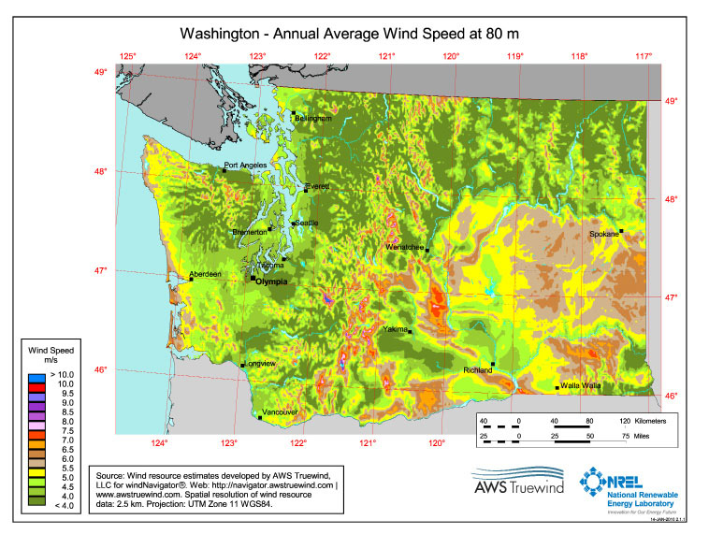
Figure 1

The cons of wind power are definitely overwhelmed by the pros. The turbines can be put anywhere with the necessary wind capacity, which, as seen in figure 1, is in many areas across Washington State. Although wind energy has almost no footprint, sometimes the wind blows more or less hard, which means that the turbines will create different amounts of electricity depending on the weather; however, according to the American Wind Energy Association, if Washington State utilized all of the best areas for wind production, wind power could power 64% of this state. Wind is a power that will never run out, and, unlike Nuclear power, requires no input from human society. It also does not require harnessing natural resources in ways that are detrimental to the environment, as in geothermal or hydropower projects. (AWEA, 2011)
Geothermal Energy
Geothermal energy is produced by running a pipe up to 6.5 km into the hot interior of the Earth’s crust and forcing high pressure water through the rock at the bottom of the pipe. A second pipe is installed at some distance to extract the water from the rock and pull it up to a power station where the heat from the water is used to run a turbine. Washington State has a number of locations that would work for geothermal power; however, a number of them lie in State or National Parks. The land in these parks can be leased for power production, but this could cause some friction with the constituents of this state. (Levitan, 2011)
The areas that are suitable for geothermal power are sorted into three categories: low temperature, medium temperature, and high temperature. Each category has a different set of uses in relation to power production. Low temperature geothermal sites can be used in agriculture to dry crops, by families to heat (or cool) their homes, or can go through a process called EGS to produce power. EGS is another word for “fracking” but not the type of fracking that has received negative press lately. Natural gas fracking uses highly toxic chemicals to break layers of rock below the Earth’s crust to release Natural Gas. This causes human and environmental health risks as the toxic chemicals spread into ground water and soils used by city water supplies, individual families who still use wells or draw their own water, and land that is used for agriculture. Fracking for geothermal electricity is much easier on the environment because all that is used is high pressure water. Initially the constituents of this state may have problems with the idea of fracking, but this important distinction removes all the negative impacts to environmental and human health. (Levitan, 2011)
Medium temperature geothermal spots can be used to heat houses, dry agricultural crops, or produce electricity, but whether or not fracking is necessary to produce energy depends on the location. High temperature spots are used primarily for energy production and have fewer risks and less money investment is necessary to begin creating electricity. The majority of geothermal spots are low temperature, but Washington State has a fair number of medium temperature spots and a few high temperature spots that could be used for power production. (Levitan, 2011)
The greatest risk of geothermal electricity comes from low and medium temperature geothermal spots that require fracking. Fracking can cause small underground earthquakes, which on their own cause no damage. However, in a region that is filled with fault lines, this process can cause a chain reaction which can trigger a major earthquake. In Basel, Switzerland, a Geothermal Plant was being built using a fracking technique, and scientists believe this is the cause of a 3.4 earthquake that hit the city. Since this event, many areas have been hesitant to try this technique, because they are concerned for the earthquake that may follow. Scientists in the USA having been doing research as to the relationship between fracking locations and fault lines to determine what is a “safe” distance for fracking to occur. Karl Garwell, a seismologist from the Geothermal Energy Association states that “the scrutiny now placed on the issue suggests that projects won’t move forward without strong indications of safety. (Levitan, 2011)” Washington State is currently working on building a map of possible geothermal sites and conducting a review of which sites are safe for fracking. An incomplete map is shown in Figure 2 with known geothermal sites listed. The IEEE states that many more sites are likely available, but little research has been done in other areas of Washington State. (Levitan, 2011)

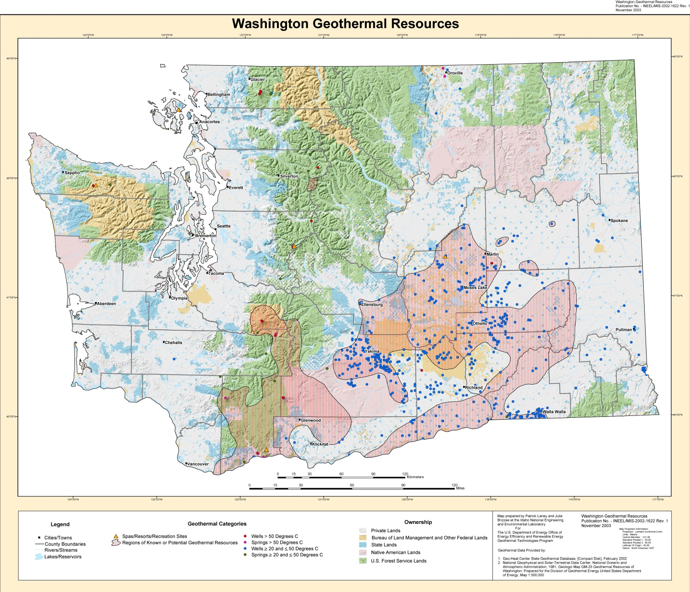
Figure 2
The cost of Geothermal energy that does not require fracking is only slightly less than the cost of using coal. The initial cost is quite high, but once implemented, maintenance is fairly cheap. Costs for sites requiring fracking is substantially higher, but economists think that the cost will not be substantially less until 2050. Besides that, the State will be able to provide electricity at almost no cost once the power plant is in place. The other pro for geothermal power is that, unlike with wind power or hydropower, the power supply is constant. The temperature of the Earth’s crust changes slowly over millennia, so the availability of power will not change from hour to hour, day to day, season to season, or year to year. This stability could be a huge asset for Washington State, especially as other regions begin to face electricity and water shortages. (Levitan, 2011)

Improvement of water use and energy efficiency to reduce demand from Built Environments:
Improving energy use and water efficiency of the built environments and infrastructure is one strategy that is recommended by climate adaptation planners for systems to prepare for climate change. The reduction of water drawn from the Columbia River Basin watershed will assist in maintaining minimum streamflow for power production and salmon runs, and the use of renewable energy sources in the built environments will reduce the electricity demand. To encourage this trend, cities, counties, and states can offset the cost of becoming green which gives financial incentive to use environmentally friendly practices.
Leadership in Energy and Environmental Design (LEED)
Already a growing trend in new construction and tenant improvement construction is the pursuit by designers, builders and real estate/land developers to achieve LEED (Leadership in Energy, and Environmental Design) certification. This system was developed and refined over the last decade by the U.S. Green Building Council (USGBC). Four levels of LEED certification can be earned for a total of 110 points possible: Certified 40-49 points, Silver 50-59 points, Gold 60-79 points, and Platinum 80-110 points. These points are earned on a development or remodel project using the following categories: Sustainable Sites, Water Efficiency, Materials and Resources, Energy and Atmosphere, and Indoor Environmental Air Quality. (USGBC, 2012)
The LEED certification process is the most widely accepted measurement in green building in the United States. Therefore, for LEED certification,buildings need to have a simulation of modeled energy performance that compares with a lower energy footprint than non-LEED buildings of similar size and use (Diamond et al 2006). In sample studies, structures built with minimal LEED standards were around 73% of the energy use of non LEED buildings in modeling and reviews after the first few years show actual energy use of the LEED buildings roughly matched the predicted numbers. Since LEED buildings are design focused versus day-to-day use focused, it is important to remember that it is still up to the occupants of these structures to practice conservation measures in the use and maintenance over the lifetime of the structure. (USGBC, 2012)
Home Appliance Incentives for Consumers and Industry:
Another increasingly used system of sustainable living is the Energy Star rating system for consumer goods/home appliances. Energy Star has been integrated into LEED certification for rating of appliances and heating/cooling systems in residential, commercial, and public buildings. This rating system is important because it gives consumers the opportunity to participate in moving towards a sustainable future, and spreads awareness of the need for climate change adaption. Appliances, heating and cooling systems, home electronics, lighting and other consumer goods rated with the Energy Star rating system can be installed in new and existing structures to decrease the consumption of energy use on standard consumer goods. This internationally recognized system has wide acceptance and use among homeowners, builders, and in public infrastructure. Refrigerators are the most energy intensive appliance in the average home energy, so replacing an old refrigerator with an Energy Star rated unit can be a very efficient way to decrease power usage. Similarly, fluorescent and LED lighting are growing in popularity and consume less than 75% of the energy of standard incandescent lighting. Additionally Energy star rates televisions, washers and driers, microwave ovens and just about any commonly used home electronic device. (Climate Institute, 2011)
Home energy and water management improvement:
One of the simplest ways to improve existing structures energy use is to simply improve the insulation of the home to retain heat in colder months. Spray insulation can be very effective at maintaining proper temperatures in a structure because it is cheap to implement, does not require tearing down walls in an already built house, and is a very effective form of insulation. If the home has batted insulation, this can be replaced by the homeowner with thicker bats for a very cost effective energy improvement. Insulation helps by keeping heating and cooling costs down in the summer and winter. (Ward, et al, 2009)
Water heaters can also be very energy intensive because they work all day to maintain water temperature to ensure that the house has warm water whenever a tap is turned on. There are a few easy solutions to lower the energy consumption of a water heater. First, a home owner can increase the insulation surrounding the water heater to decrease energy transfer. Many governmental agencies also subsidize the installation of water heater timers, which turn off the water heater at night and during times when no one is typically using hot water. For a more intensive change, many agencies are now giving rebates on solar hot water heaters, which use a traditional water heater hooked up to a solar heater on the roof of the building to maintain water temperatures. All of these actions can assist in decreasing energy usage in heating hot water for a residential building. (Ward, et al, 2009)
Harvesting of rainwater is another measure which can help conserve water, especially during the summer months. The water can be stored for irrigation, toilet use and with proper treatment potable uses (washing dishes, taking showers, even drinking!). Cisterns located high on a building can use gravity to aid in distribution which can also help in emergency situations when water is not readily available. Plumbing buildings for graywater separation or “purple pipe” can also reduce water demands of a building. This plumbing method collects wastewater (not from toilets, but from hand sinks, dishwashers, and kitchen sinks), to be used for landscape irrigation, and stores it on-site in cisterns with built in water treatment capabilities. This is measure is more cost effective for new construction than retrofitting existing homes and buildings due to the need for separate purple pipe drain lines within the walls of the home. (Ward, et al, 2009)
Sustainable Landscaping:
Sustainable landscaping of sites around buildings and homes can incorporate some key measures within recommended LEED principles. Planting trees to cover surfaces in shade along with green rooftops in urban areas can help reduce the heat island effect. Urban areas tend to absorb heat more than surrounding rural areas and can increase the need for cooling of homes and buildings. The use of lighter pavement materials helps to absorb less heat than darker surfaces. Green rooftops can be literally vegetation or painting the roof a lighter color which will reflect sunlight back into the atmosphere. The vegetation will also provide a method of slowing down rainwater runoff which will help groundwater to recharge and prevent drainage system overflow. Planting native vegetation or plants that need less watering across the site is another measure which will demand less water. Installation of permeable pavement materials can control runoff on a site by allowing for proper ground absorption. This also aids the property in contributing to proper ground water recharge. (Ward, et al, 2009)
Financial Incentives for green building:
Along with the savings that go along with reducing energy and water use in green building techniques are financial incentives that can be offered at the Federal, State, and local level for government, consumers, industry, and non-profits. These savings can come in the form of tax breaks, subsidies, or rebates. (EPA, 2012)
Tax Breaks are when you purchase or install a fixture in your home and for doing so, the local, state, or federal government gives a write off for your taxes. This decreases the amount of money that you need to pay in taxes at the end of the tax year. Tax break information is usually available through the supplier’s web site or through government web pages. This incentive is most effective with home owners or property owners, so this financial incentive would work best for remodeling/retrofitting projects or installation of energy star consumer goods. For example, Energy Star, which is run by the Federal Government, offers consumer Tax Credits for consumers for home improvement and credits available for new construction. (Energy Star, 2012)
Subsidies are when the government decides to offset the upfront price of a project, sustainable materials or specific parcels of land to be developed by paying some portion of the cost for the consumer or builder/developer. Examples could be a subsidy by local government for graywater plumbing to reduce water demands from a watershed or a statewide subsidy to encourage urban density in certain areas which can reduce urban sprawl. (EPA, 2012)
Rebates are usually consumer based market incentives for purchasing new products. These come in the form of decreased prices or mail in forms. Basically, a consumer goes to a store to purchase an appliance, and at the store the sales associate shows them the rebate information. The consumer purchases the good at full price, fills in a form, mails it to the proper authority, and receives a check refunding some portion of the money to the consumer. This works well for renters who are purchasing small appliances, such as microwaves or toaster ovens, for home owners who are replacing major appliances, such as refrigerators or driers, or for developers who are installing environmentally friendly appliances in a new building. (Energy Star, 2012)

Columbia River Basin Hydroelectric Power Production Adaptation Plan:
Aquifer storage and recovery is the best strategy for increasing water storage capacity. This is a less resource intensive option than heightening dams, and there are fewer negative environmental impacts associated with this strategy. It diversifies water supply options, which increases adaptive capacity and decreases vulnerability. The advantages of implementing aquifer storage and recovery outweigh the drawbacks and of all of the possibilities for increasing water storage, a key component of any Columbia River Basin adaptation plan, this strategy is the most viable, direct, robust, and flexible. There is great potential for aquifer storage and recovery in Washington state, but more resources and authorities would need to be dedicated before it could be implemented, making it a tier 2 action (Snover et. al, 2007).
For diversifying the energy production of Washington State, this report recommends using a mix of solutions to ensure that this state is provided with reliable electricity for the coming century. By using a combination of Wind Power and Geothermal Power, Washington can insulate itself from problems by choosing only the best site for each type of power production.
This strategy is necessary for adapting to changing water supply, but it is not a very flexible solution. Producing new and varied forms of electricity production is expensive, time intensive, and once implemented, cannot be changed. This makes it a distinctly tier 2 adaptation plan. Much research has gone into determining the risks and benefits of each option, and now the weight of that research needs to be used to decide what the best fit is for Washington State. The best solution to insulate this state from possible problems in power production is to use a variety of approaches to ensure that if one fails, the others can still succeed. Law makers must understand the positive and negative impacts of each option, and ideally choose a mix of the available choices to ensure that Washington has a secure energy future. (Snover et al, 2007)
By splitting the requistite energy production between two sources, the government can choose the easiest to access, most productive, and safest sites for power production. For Geothermal power, this will ensure that little fracking is necessary which in turn will decrease the likelihood that earthquakes will be caused by energy production. Geothermal power is a steady power source, not changed by streamflow, sunlight, or rate of wind. This ensures that even in times of low streamflow and low wind the state will still have enough power to run. The Wind Power plants can provide large portions of Washington’s electricity and provide industry to the state in the form of producing the products to build the wind turbines and provide income to local farmers who lease land to the state for turbines to be installed. The combination of these two strategies will boost the economy and insulate this state from future climate change problems.
Improving energy use of the built environments and public infrastructure is a priority strategy that we recommend. Specifically retrofitting and remodeling of existing homes such as improving insulation to save on home heating use. This strategy is viable because the technology required for implementation exists. It is direct because it gets immediate energy conservation results, and it is robust because this process will stand the test of time given all project climate scenarios. It is also flexible because it is low cost compared to other strategies for energy conservation strategies.
This is a Tier 1 strategy due to the technology, in both bat form and in spray form, being readily available for homeowners to implement. If financial incentives, specifically rebates on the cost of materials and labor (if hire a contractor), are offered at Federal, State or local level, then energy consumption of the typical home will become more efficient and decrease demand for energy provided by hydropower.

Conclusion:
Climate change will cause major shifts in climatic patterns in the Pacific Northwest and adapting to these changes is crucial for many different stakeholders, including hydropower interests, who rely on the resources provided by the Columbia River Basin. Implementation of adaptation strategies is inhibited by many different problems. Adaptation actions in the water sector, the sector most relevant to hydropower, are subject to institutional or legal constraints, which greatly slows any progress in water resource management, water policy, and water allocation to be made (Binder, 2009). Climate change science is not often incorporated into resource planning and management practice. Foresight is planning is often lacking in part due to the fact that the climate changes gradually, which hinders addressing climate change effectively. Rather, changes in management are often in response to crises (Binder, 2009).
In the energy sector, projected increases in demand inhibit easy adaptation. Hydropower resources will be stressed by climate change and there are limitations on the ability of other renewable resources to meet growing energy needs. There are many tradeoffs associated with changing management strategies to increase hydropower production in the summer including loss of summer recreation and loss of some winter hydropower production (Binder, 2009).
Despite the barriers posed to both the water sector and the energy sector. It is necessary to begin adaptation planning, resource allocation, and state and federal deliberation as soon as possible. Climate change adaptation will need to integrate governance levels, science, regulation, policy, and economics to manage the wide range of impacts on the Columbia River Basin. This integration will involve the development or modification of laws, regulations, and policies, legal proceedings in the courts, changes in institutional culture, channels of communication, and building trust between government agencies and their stakeholders.

Citations:
PowerScoreCard. 2012. Electricity from Hydro. PowerScordCard, White Plains, NY. Available from: http://www.powerscorecard.org/tech_detail.cfm?resource_id=4
Access Washington 2012. Aquifer Storage and Recovery. State of Washington Department of Ecology: Access Washington, Lacey, WA. Available from: http://www.ecy.wa.gov/programs/wr/asr/asr-home.html
Working Lands and Waters Topic Advisory Group 2011. Washington State Climate Change Response Strategy. Working Lands and Waters Topic Advisory Group, Seattle, WA. Available from: http://www.ecy.wa.gov/climatechange/2011TAGdocs/R2011_interimreport.pdf
Northwest Council 2012. Dams: Impact on Salmon and Steelhead. Northwest Council, Portland, OR. Available from: http://www.nwcouncil.org/history/DamsImpacts.asp
Ward, A. and Wilson, A. 2009. Environmental Building News, Internet Only. Available from: http://www.buildinggreen.com/auth/article.cfm/2009/8/28/Design-for-Adaptation-Living-in-a-Climate-Changing-World/
United States Green Building Council 2012. About USGBC. United States Green Building Council, Washington, D.C.. Available from: http://www.usgbc.org/DisplayPage.aspx?CMSPageID=124
National Association of Metropolitan Water Agencies 2009. Confronting Climate Change: An Early Analysis of Water and Wastewater Adaptation Costs. National Association of Clean Water Agencies, Washington, D.C. Available from: http://www.nacwa.org/images/stories/public/2009-10-28ccreport.pdf
Binder, L. Whitely, et al. 2009. Preparing for Climate Change in Washington State. Washington Climate Change Impacts Group, Seattle, WA. Available from: http://cses.washington.edu/db/pdf/wacciach11adapt654.pdf
United States Department of the Interior: U.S. Geological Survey (USGS). 2007. Reducing Earthquake Hazards in the Pacific Northwest. United States Geological Survey, Washington, D.C. Available from: http://earthquake.usgs.gov/regional/pacnw/
New York Times 2011. Japan-Earthquake, Tsunami, and Nuclear Crisis (2011). New York Times, New York, NY. Available from: http://topics.nytimes.com/top/news/international/countriesandterritories/japan/index.html
Dininny, S. 2010. Hanford Washington Site: Radioactive Levels Ten Times Lethal Limit at Cold War Nuclear Reservation. Huffington Post, Yakima, WA. Available from: http://www.huffingtonpost.com/2010/11/18/more-radioactive-contamin_n_785358.html
American Wind Energy Association (AWEA) 2011. Wind Energy Facts: Washington. American Wind Energy Association, Washington, D.C. Available from: http://www.awea.org/learnabout/publications/upload/Washington.pdf
Levitan, D. 2011. Geothermal Energy’s Promise and Problems. Institute of Electrical and Electronics Engineers, Washington, D.C. Available from: http://spectrum.ieee.org/green-tech/geothermal-and-tidal/geothermal-energys-promise-and-problems
Geothermal Research Group (GRG). 2003. Washington Geothermal Resources. Geothermal Research Group, Pullman, WA. Available from: http://www.energy.wsu.edu/documents/wa.pdf
Mueller, B. 2012. Interview: Betty Mueller’s Experience with Wind Power. Conducted by Claire Mueller, February 4, 2012.
Bureau of Reclamation, 2012. The Story of the Columbia Basin Project-Washington. US
Department of the Interior, Washington, DC. Available from http://www.usbr.gov/pn/project/
columbia_index.html# (accessed on February 1st, 2012)
Elsner, M., Cuo, L., Voisin, N., Deems, J., Hamlet, A., Vano, J., Mickelson, K., Lee, S.,
Lettenmaier, D. 2010. Implications of 21st Century Climate Change for the Hydrology of
Washington State. Climatic Change 102:225–260.
Hamlet, H., Lee, S., Mickelson, K., Elsner, M. 2010. Effects of projected climate change on
energy supply and demand in the Pacific Northwest and Washington State. Climatic Change
102:103–128.
IPCC, 2007: Summary for Policymakers. In: Climate Change 2007: The Physical Science Basis.
Contribution of Working Group I to the Fourth Assessment Report of the Intergovernmental
Panel on Climate Change [Solomon, S., D. Qin, M. Manning, Z. Chen, M. Marquis, K.B.
Averyt, M.Tignor and H.L. Miller (eds.)]. Cambridge University Press, Cambridge, United
Kingdom and New York, NY, USA.
Lang, B. 2005. Columbia River. The Center for Columbia River History, Vancouver, WA.
Available from http://www.ccrh.org/river/history.htm (accessed February 1st, 2012).
Markoff, M., Cullen, A. 2008. Impact of Climate Change on Pacific Northwest Hydropower.
Climatic Change 87:451–469.
Miles, E., Snover, A., Hamlet, A., Callahan, B., Fluharty, D. 2000. Pacific Northwest Regional
Assessment: the Impacts of Climate Variability and Climate Change on the Water Resources of
the Columbia River Basin. Journal of the American Water Resources Association 36: 2.
Mote, P., Salathé Jr., E. 2010. Future Climate in the Pacific Northwest. Climatic Change 102:29–
50.
Northwest Council, 2012. Columbia River History: Irrigation. Northwest Council, Portland,
OR. Available from http://www.nwcouncil.org/history/Irrigation.asp (accessed on February 1st,
2012).
Salathé Jr., E., Leung, L., Qian, Y., Zhang, Y. 2010. Regional climate model projections
for the State of Washington. Climatic Change 102:51–75.
Energy Star. 2012. Federal Tax Credits for Consumers Energy Efficiency. Energy Star, Washington, D.C. Available from: http://www.energystar.gov/index.cfm?c=tax_credits.tx_index
EPA. 2012. United States Environmental Protection Agency. EPA, Washington, D.C. Availability from: www.epa.gov
Climate Institute. 2012. Energy Star. Climate Institute, Washington, D.C. Available from: www.climate.org
Title Page photos:
Drought tolerant plants
http://www.gardenshowblog.com/events/design-a-garden-week-4-plant-groups/
Energy Star Logo:
http://www.crownboiler.com/Programs-And-Promotions/Energy-Star
Geothermal:
http://www.pikeresearch.com/research/geothermal-power
Wind Power:
http://science.howstuffworks.com/environmental/green-science/carbon-tax1.htm
CRB Dam:
http://www1.eere.energy.gov/tribalenergy/guide/hydropower_large.html

