Unifying Lake City:
Developing a Cohesive Neighborhood

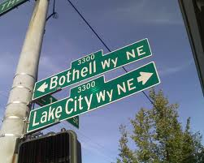

Next Steps of the Design Process:
A Compilation of our Findings

By:
Claire Mueller
Allison Hamburg
Tyson Hiffman
Matt Brophy
Unified Vision

One of the most notable outcomes of this community exploration process has been the connection between different groups and the Unified Vision that seems to be manifesting among them. We have found that, even though some people are not aware of other’s goals in the development of the community, they all seem to be expressing relatively similar concerns. While the project is still in its infancy, some key factors of concern have been identified by the groups that have been involved in the process thus far. As Lake City transitions, these concerns can be used as guidelines that will give the process direction.

The concerns expressed are discussed in more detail within the body of this report, and are defined as follows:
I. The need to create pedestrian and cyclist paths connecting Lake City to the surrounding area and into one cohesive neighborhood.
II. The need to implement “Destination-based” planning.
III. The value of the ethnic diversity in the area and how to connect with it.
IV. The need for increased community gathering space and spectacle.
V. Future Opportunities

In combination with these guidelines there is a long list of ideas that the neighborhood can use to move forward.

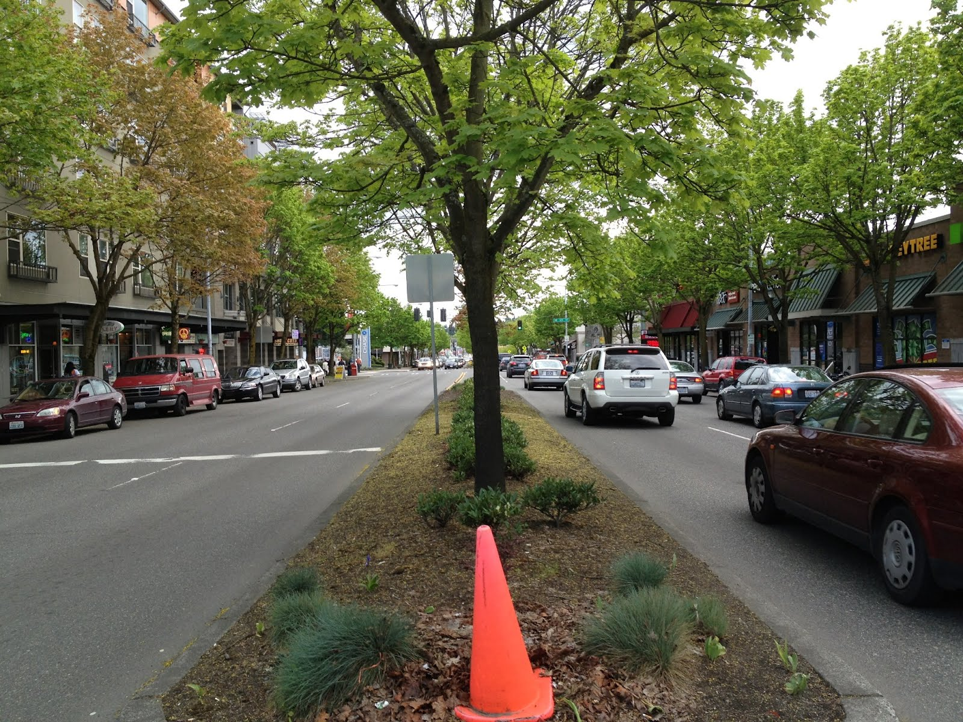

I. Pedestrian and Cyclist Connections

Mental Mapping, Walk-around-the-Block, Lynchian Mapping, and Observation activities all noted the severe lack of alternative transportation. The Lynchian Mapping Group noted in their analysis that all paths in the neighborhood seemed to be geared towards cars. The paths that pedestrians and bikes use are widely makeshift uses of car paths, ie: streets with no sidewalks where pedestrians use the shoulder of the road. This forces pedestrians and cyclists into dangerous situations by forcing them to share space with vehicles. With Lake City historically being a car dominant area, there is a severe lack of walking and biking infrastructure. While the neighborhood is widely accessible by bus, additions are needed to make it easy to move around the neighborhood, not just through it.
One of the largest obstacles facing the Lake City community is Lake City Way itself. The largest Node in Lake City was identified by every field research group as 125th and Lake City Way. Sadly, this cross street is also the epicenter of car traffic in Lake City, making it a dangerous and busy intersection. One of the major comments that came out of the Saturday workshop, as well as an idea that came from every student group, was that Lake City Way has become a divider, rather than a connector, for the community. Unfortunately, Lake City Way is also a major state highway and an integral artery of the transportation system. There is no feasible way to divert traffic from it or relocate it. Because of this, Lake City Way must be embraced and plans must be set forth to facilitate pedestrian crossings.
There are a plethora of options that can facilitate crossing Lake City Way but it is a matter of the most cost-effective and productive method that is in question. Crosswalks can be effective as they are cheap and relatively easy to implement. The problem with this is that Lake City Way (Hwy 522) is a major highway and, for the most part, travels at speeds above 40 miles per hour. With the recent addition of a toll on the 520 bridge, more and more drivers are choosing alternate routes around Lake Washington which includes using Lake City Way. With growing levels of traffic on an already busy road, it may be difficult to persuade passers-through to embrace an even slower travel time, and the neighborhood might see pushback from the State Department of Transportation. Other options include pedestrian bridges either over or under Lake City Way. While this would be the most effective in terms of not disrupting traffic, these options are typically quite expensive and are utilized less than people might think. Some examples include the pedestrian bridges over Interstate 405 and the pedestrian bridges around 155th and State Highway 99. Finding a way to cross Lake City way is paramount to future development, but is an aspect of the project that will require further investigation and analysis.
Several community members at the Saturday Community meeting, as well as people who were spoken to in the initial mapping and observation exercises, also expressed unhappiness that the Burke-Gilman trail is so cut off from Lake City. The Burke-Gilman not only conveniently transports hundreds of people a day past Lake City, but it could also be a huge asset to Lake City commuters who would like to try an alternate form of commuting. Connection to the Burke-Gilman could provide economic, safety, and health benefits to the community.

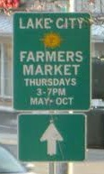

II. Destination-based Planning

During the Saturday morning workshop, it quickly became apparent that everyone understood what Lake City needs to thrive economically: there must be something drawing people into the area from outside of the neighborhood. This idea was also expressed during other processes such as Lynchian mapping, observation activities, and mental mapping, as community members and students tended to identify destinations that people see as landmarks in the community as being quite important. For economies to grow there must be some way to generate revenue from sources outside of the people living in the area. This can be done in two ways. There must either be a product produced in the area that people buy from outside of it or there must be a reason for people to come to the area and spend their money. Considering the general lack of open-space for manufacturing, and given the visions that the local community members have for a unique, inviting community, it seems most reasonable to create some sort of destination that people are interested in experiencing. There are endless possibilities as to what kind of business could fill this role. For instance, community members have expressed interest in a music-center for the City of Seattle and advertising Lake City as a destination for musicians in the greater Seattle area. Another idea focused on a water park that could be used as an ice-rink in the winter or a pool in the summer.
This idea of “destination-based” planning seems to be one of the most powerful ideas to emerge from our exploratory sessions. It is through this extremely elementary idea that planners should frame all of their work. Without a reason to come to the area or something to buy from the area, money will not be injected into the local economy, making it very difficult to grow, develop, or maintain the neighborhood.

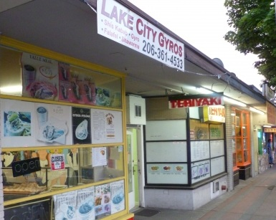

III. Ethnic and Economic Diversity

During our demographic analysis of the area it was discovered that within the communities of Lake City there are over 27 languages spoken. This came as quite a shock to the majority of the community members. While those connected with this planning process were aware of the apparent ethnic diversity of their neighborhood, they had no clue as to the extent of the diversity. One of the main priorities in the next stage of this process should be to gather the inputs from the minority and ‘undesirable’ people of Lake City.
Low income housing and the homeless population was a recurring theme during both the field research process and community meetings. This topic can be somewhat controversial, but without having input of the parties being discussed present in the data or the workshops, no steps can be made towards mitigating low incoming housing or homeless issues in the area.
To begin closing the gap between the underrepresented and the active participants in the planning process, the groups that are not showing up at community meetings must be found and their concerns must be heard. It is through embracing the diversity of the area that Lake City will be able to organically develop a cultural identity. For this to happen, diligent outreach is necessary to contact and connect with the many different groups in the area. Through surveys, mailings, and by creating discussions and asking questions in diverse settings like food banks or low income child care centers, hopefully people will emerge who have not yet been heard.

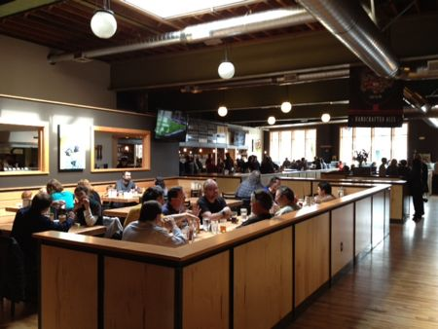

IV. Community Gathering Space

The Civic Core of Lake City was identified by the Observation, Walk-around-the-block, Lynchian, and Mental Mapping groups as an increasingly important part of the Lake City neighborhood. The Saturday Community Meeting identified it as the place where families can meet, where classes can be held for immigrants, and where social gatherings within the community, such as movie nights, Pioneer Days, and AA meetings, can occur. The residents of Lake City have identified this space as extremely important to the burgeoning community. Bill Pierre owns property at the center of the Civic Core (The Pierre Service Center, the vacant Church lot, and the space that the Tire Center, Watch Shop, and Bean City Espresso are currently in). At the Saturday Community Meeting, both groups that worked on redevelopment schemes for the Civic Core included new community spaces, such as community gardens, an amphitheatre, a space for the farmer’s market that doubles as a space for social gatherings, midnight movies, etc. In addition to the Saturday Community Workshop groups’ results, it should be noted that the Civic Core also contains the only other areas for social gathering: the Library, Community Center, Koffee Klatch, Elliot Bay Brewery, and a small playground behind the Library. Therefore, this area already holds the potential for being the central district of Lake City’s community.
The neighborhood parks also hold a lot of potential for future opportunities as they were all identified as either in need of general maintenance, or being under utilized for a variety of reasons. The most commonly identified factors of these issues were lack of ownership by the community and the presence of undesirable people. Another reason was given for wanting improvements in the case of the mini-park: many community members said that they feel very exposed and uncomfortable sitting in a noisy intersection. This space was also identified through the behavioral observations as being used mostly as a thoroughfare and not as a space where people stopped to spend time.
In addition to the Civic Core and the parks, the community has identified key social gathering spaces that could be used to foster community. These include businesses that support large groups of people or casual meeting spaces for Lake City residents. Koffee Klatsch and the wildly popular Elliot Bay Brewery were both mentioned numerous times in Mental Maps, as well as at the Saturday Community Meeting, and in our Social Observations. These two businesses are within the Civic Core, but they brought up ideas and memories of spaces in other areas of Lake City. Many people noted the Cranium’s Coffee Shop as a space that should have survived, but for some reason did not. This type of space, a place where community members can spend time and get to know each other, is extremely important in building community. Several of the groups at the Saturday Community Workshop discussed types of business that could be used for Community Building. These include: coffee shops, music venues, community art displays, youth engagement projects, and a cultural community center.
Several of the groups also noted the importance of having “civic areas” along Lake City Way all the way to the North and South boundaries. At the very southern boundary, there is an odd triangular block that is split for infrastructural purposes. Both groups that worked on this block tinkered with the idea of having a plaza instead of a street, to open up a pedestrian only shopping node, as well as to provide community space in an area that is currently desolate of community life. Further north, between 120th and 123rd on Lake City Way, one group had similar ideas with all of the buildings on that block creating large open spaces between buildings that are for business patrons to use as community gathering spaces.
Community gathering space and some sort of spectacle were central to the concerns of all the explorative groups. There was a strong understanding among local residents that if there is no recreation in the area and there is nothing to draw people in, then there will be no way to keep people interested in the space. Whether it is through the development of the Pierre properties or through an overall revamp of the local street facades, there must be something to look at when people pass through the area. An interesting, uniquely individual space was central to the vision of the locals. This can be done through the implementation of fountains, parks, street art, or anything else that will make the local area stand out to those who pass through.
Since the Pierre family is concerned with fostering a space which suits the local residents, these identified concerns will stand as the foundation for future planning efforts. Planning is a process with evolves organically based on each individual project. While those involved in the process should remain flexible and open to new ideas and concerns that may arise, the above identified areas will provide a context in which to plan effectively while maintaining consideration for those who will use the space the most.

V. Future Opportunities

This process has led to an abundant flow of ideas for future opportunities in Lake City. Because the neighborhood is somewhat raw in terms of pedestrian infrastructure and public space, there are endless ways in which Lake City can redefine itself and become more appealing to stakeholders. The strong support already behind the Thorton Creek restoration extends these opportunities beyond the typical additions of sidewalks and grocery stores. Taking the momentum of its current transition, Lake City could blossom into a eco-friendly neighborhood in lieu of its auto-oriented past. Future opportunities in Lake City include green urban infrastructure such as:
- Bioswales
- Rain gardens
- Sustainable urban drainage systems
- Bioretention systems

In addition to moving towards a more green and no longer car dominated environment, the community identified the need to move away from a “highway community” image. The strip clubs and dispensaries that currently define the neighborhood, need to be replaced with new defining qualities. While much of this is dependent on redevelopment, the community can do its fair share as well. Neighborhood beautification projects can be started and carried out by current residents to draw stakeholders in. Some examples of projects could be:
- Murals
- Litter clean up crews
- Added seating at the Mini-park
- Neighborhood watch groups

Taking advantage of Lake City’s current position as a commuter passage is another way that the neighborhood could bring in businesses and gain city support to add pedestrian connections. Lake City has several high volume bus stops along Lake City Way and 35th Ave. Observations showed that much of the pedestrian traffic was to and from these bus stops. The Fred Meyer observation team also observed people using the parking lot as a park and ride. In addition to this, the neighborhood’s demographics show that there is a concentration of people without cars on or near Lake City Way, which can be interpreted to mean that the car traffic is coming from outside the area. The combination of this data points toward a possible transportation hub, which was supported by several groups at the community meeting. Possible businesses include:
- Coffee shops
- Food trucks
- Park and ride

With this unique opportunity for redevelopment, Lake City is equipped to move forward in search of input from a wider range of residents, in the pursuit of creating an identity for the neighborhood that resembles that of other successful Seattle social hubs.

