HYDROELECTRICITY IN THE COLUMBIA RIVER BASIN:
EFFECTS OF CLIMATE CHANGE
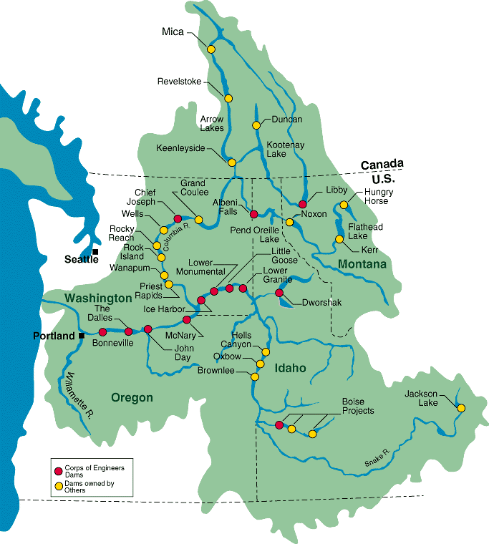

CEP 302
February 5, 2012
Claire Mueller, Caitlin Budd, Tim Calderwood
Introduction: 1 page

The Columbia River is system is the most hydroelectrically developed river system in the world (Center for Columbia River History [CCRH], 2005). In a single year it can produce more than 21 million kilowatts of energy (CCRH, 2005). This river system is able to provide 950 million dollars’ worth of electricity of year, providing a substantial portion of Washington’s energy and, in addition, providing revenue through the sale of electricity to other states, namely California (CCHR, 2005; Bureau of Reclamation, 2009). As climate change becomes more of a pressing issue, it is important that Washington State looks at how this will affect the Columbia River Basin and its ability to produce power.

Hydroelectricity is the world’s first truly renewable resource (CCRH); however, it only lasts as long as stream flow maintains a minimum rate. As climate change begins to impact the Columbia River Basin more intensely, Washington State needs to explore how that change will affect hydroelectric power production to mitigate the possible negative impacts on power production. There are many factors that affect stream flow and a dam’s ability to produce power. They range from ecological issues (such as salmon habitat) to economic issues (such as barges ability to move up and down the river with goods) to snow melt (such as when snow accumulates and melts). This section will explore the future of hydroelectricity production on the Columbia River system within the constraints of stream flow change.

As climate change impacts the Columbia River Basin more intensely, scientists predict that less precipitation will fall as snow, but there will be more precipitation overall (Elsner, et al. 2010). Historically, the Columbia River Basin has been fed from spring until late summer by snow melt, which comes off of the mountains as temperatures rise. With climate change, the temperatures will be higher year round, meaning that snow does not build up in the mountains. The summers will be drier than they are now, which means that the summer stream flow will be very low. In addition, while it will rain more overall, the rain will flow down the river at the time that it falls, possibly overwhelming the dams and causing floods, and not creating electricity in the summer, when it is needed. These projections are found through climate models and scenarios, of which there are hundreds. Global climate models are systems of differential equations derived from the basic laws of physics, fluid motion, and chemistry meant to be solved on supercomputers. The computers create a 3-D grided projection of the world. The different emission scenarios referenced in this paper represent possible futures. Factors taken into account to project these future scenarios include governance, population, economy, social structures, and institutions.

This paper will look at climate models put forth by the world’s leading scientists to determine the impact climate change will have on hydroelectric power production in the Pacific Northwest. The Columbia River Dam system provides more than 70% of Washington State’s electricity, so this paper will more specifically discuss how power production in Washington State dams will change (CCRH, 2005). Understanding this will allow this state to create a plan to mitigate and adapt to the changes that it will face in the years to come.

Climate Change in the Columbia River Basin: 1.5 page

Climate change is likely to affect temperature, precipitation, and snow melt/snow pack in the Columbia River Basin. The general trend of multiple models projects that temperature will increase in both summer and winter, with a greater increase occuring during the summer (Markoff et al. 2007) (Fig. 1). Annual temperature in the Pacific Northwest is expected to increase by 1.1 ◦ C (2.0 ◦ F) by the 2020s, 1.8 ◦ C (3.2 ◦ F) by the 2040s, and 3.0 ◦ C (5.3 ◦ F) by the 2080s, compared with the average from 1970 to 1999, found by averaging all of the climate models used in the IPCC 4th Assessment Report (Mote and Salathe 2010). It is also important to note that, according to Elsner (2010), the effect temperature has on hydrology is not as obvious as the effect of precipitation. Therefore, it is difficult to distinguish which factor, temperature or precipitation, is attributable to hydrological changes, which is why the two factors should be looked at independently. The Columbia River Basin is sensitive to increasing temperatures because snowmelt dominates seasonal runoff, and temperature changes impact the rain/snow balance.

Precipitation

The Columbia River Basin relies on winter precipitation (defined as October through March), which makes up most of annual precipitation, and the resulting snowpack to maintain spring through summer streamflows (defined as April through September) (Elsner et al. 2010). Higher temperatures will cause less precipitation to fall as snow during the winter. They will also cause seasonal snowmelt to occur earlier in the year. Both the amount of snow that accumulates and the rate of snowmelt determine annual streamflow, but other forms of precipitation also play a role. Annual precipitation changes differ noticeably from one scenario to another, and thus the projected streamflow is variable between models. An example of this variation between scenarios is the difference Markoff et al. (2010) noted between CCSR/NIES A1FI and CSIRO-Mk2 B1. With predicted increases in winter temperature and precipitation under CSIRO-Mk2 B1, simulated streamflows are projected to increase December through May, whereas under the most extreme model, CCSR/NIES A1FI (predicts higher temperatures with lower precipitation) total streamflow is projected to decrease during this same time period (Markoff et al. 2007).

Temperature

Warming plays a prominent role in determining the amount of future snowpack and can counteract potential increases in precipitation, making disparities in precipitation projections between models less important (Salathe et al. 2010). Based on 20 GCMs and 2 emissions scenarios, projected annual precipitation changes over the PNW range from −9% to +12% for the 2020s, −11% to +12% for the 2040s, and −10% to +21% for the 2080s. Seasonally, precipitation is expected to increase in winter and decrease in the summer (Elsner et al. 2010). This is in agreement with the trend of wetter autumns and winters and drier summers found in most of the models in the IPCC AR4 (IPCC). The set of models used in the IPCC report are different than the set used by Elsner.

Snow Dominant versus Rain Dominant Watersheds

The Pacific Northwest has three different types of watersheds: snowmelt dominant, rain dominant, and transient. Snowmelt dominant watersheds are characterized by precipitation stored as snowpack causing low flows in winter and peak flows resulting from the melting of snowpack in late spring or early summer. Rain dominant watersheds are characterized by peak streamflow occurring in the cool season, November through January. Watersheds that experience two streamflow peaks, one from heavy precipitation in winter and the other from snowmelt, are called transient watersheds because they receive both snow and rain. Currently, the Columbia River Basin is a snowmelt dominant watershed. The April 1 snow water equivalent (SWE), the amount of water contained in snowpack, is projected to decrease by approximately 38–46% by the 2040s (compared with the mean SWE between 1917–2006), based on composite scenarios of B1 and A1B, respectively, which represent the average effects of all climate models. By the 2080s, seasonal streamflow timing will shift significantly in both snowmelt dominant and rain/snow mixed watersheds. With the effects of climate change, the Columbia River Basin is expected to become a transient watershed. Evidence of the Columbia River Basin transitioning toward a transient watershed is evident through changes in the mean hydrograph at The Dalles, the outlet of the Columbia River Basin watershed, which shows reduced peak flow in the late spring and early summer and increased cool season flow in connection with reduced snowpack (Elsner et al. 2010) (Figure 2).

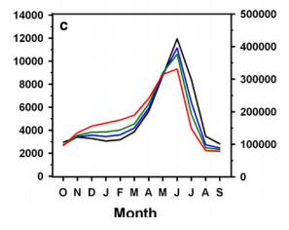

Fig. 2 Columbia River Basin at The Dalles. Hydrographs showing monthly averages of simulated daily streamflow for 1917-2006 (black) and 2020s (blue), 2040s (green), and 2080s (red), using the A1B SRES scenario. The left y-axis (Natural flow cms), the right (Natural flow cfs) (Elsner et al. 2007).

Hydroelectricity and Climate Change: 2 page

Columbia River Basin hydropower, which is central to the region’s energy supply, is vulnerable to the impacts of climate change (Markoff et al. 2007) because all of the factors affected by climate change (temperature, precipitation, and snowmelt/snowpack) determine streamflow, the main power source. According to Hamlet et al. (2010), by the 2020s, regional hydropower production is projected to increase by 1.0–4.5% in winter, decrease by 8.6–11.0% in summer, with annual reductions of 0.8–3.4%. By the 2040s, hydropower production is projected to increase by 4.7–5.0% in winter, decrease by about 12.1–15.4% in summer, with annual reductions of 2.0–3.4%. By the 2080s hydropower production is projected to increase by 7.7–10.9% in winter, decrease by about 17.1–20.8% in summer, with annual reductions of 2.6–3.2%.

Timing of Snowmelt/Runoff

Hydropower production is sensitive to the timing of runoff. With climate change, the timing of runoff is expected to change because snow will melt earlier in the year. Currently, snowmelt in the spring and early summer, in addition to water stored in dam reservoirs, provides enough streamflow to sustain hydropower production through the drier months. Thereby, hydropwer production in from June – September is the most vulnerable to the snowmelt runoff timing shift (Markoff et al. 2007).
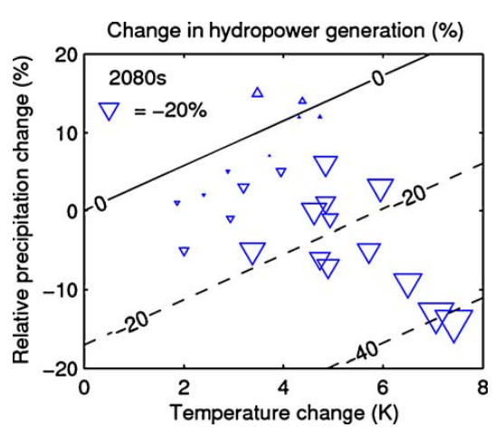
Fig. 3 Predicted change in annual hydropower generation (%) asa bivariate function of change intemperature and precipitation from GCM output for the 2080s. Size of triangle symbol indicates magnitude of change in hydropower generation. (The legendshows a triangle corresponding toa 20% decrease. A triangle withsides twice as long corresponds toa 40% decrease.) Triangles pointing up represent increaseswhile triangles pointing downrepresent decreases. Isolines of hydropower generation are basedon a regression model derived using annual temperature and precipitation change as predictorsare plotted at 0, −20, and −40% relative to current levels (Markoff et al. 2007).

Temperature and Precipitation Impacts on Power Production

Based on the CCSR/NIES A1FI, CSIRO-Mk2 B1, and ECHAM4 scenarios, for the A2 and B2 emission scenarios, the 2080s period is selected to show a wide range of predicted temperature and precipitation changes, ranging from slight increases to large decreases. The data suggest that a 3% change in precipitation has a similar impact on hydropower to a 1°C change in temperature. In other words, every 1°C increase in temperature requires an approximately 3% increase in precipitation to maintain current levels of hydropower generation. Therefore, in order to compensate for changes in streamflow, to which the timing of snowmelt runoff contributes, wintertime precipitation must increase by about 9% in order to maintain current hydropower revenues. Of all the 2020s scenarios, CSIRO-Mk2 B1, which predicts a 9.4% increase, is the only scenario that would compensate with wintertime precipitation. These projections were made using the A2 scenario for the 2020s from each GCM (Markoff et al. 2007).

The ColSim reservoir operations model is a monthly timestep model simulating the major features of the Columbia River water resources system under the current operating policies and is for understanding seasonal effects and climate impacts on the water resources system of the Columbia River Basin (Miles et. al 2007). Figure 4 uses ColSim to model the changes expected in hydropwer based on the most extreme, the least extreme, and two intermediate scenarios. All scenarios, but th least extreme, B1, predict at least a decrease in a GW of electricity coming from hydropower production. The value of this loss in hydropower generation is complex to understand in relation to economics (Markoff et al. 2007).
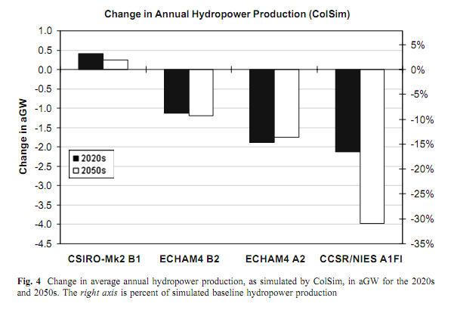Fig. 4 Hydropower revenues. The right axis is percent of simulated baseline revenues (Markoff et al. 2007).

Uncertainties in Projections: 1.5 pages

There are many uncertainties regarding future climate change impacts to hydroelectric power in the Columbia River Basin. Many factors are not understood with the Global Climate Models in use by the scientific community. The climate scenarios that have been used in this paper cannot accurately predict such factors as population growth in the region, regional development, economic growth and recession. In addition to these unknown factors, there are uncertainties within the projections of temperature, precipitation, and stream flow as well. These uncertainties come from differences between the type and specific models used, scenarios used, and general uncertainty about the future.

Climate Models

Which type of model is used can affect the outcome of a scenario because the two types of models have different data input. There are two types of climate models, Global and Regional. Regional climate models have more detail per mile because they are scaled to a smaller scale, whereas Global climate models have a similar amount of data, but are scaled to a much larger area. Global Climate Models have some advantages over Regional Climate Models due to the computational expense of the running regional climate scenarios. In other words, because regional climate models have a much smaller scope, it can be more expensive to collect the necessary data due to fewer organizations working in the area and more detail necessary in each area. This is due to the systematic differences or biases of global model observations and which can utilize statistics. Therefore some bias correction needs to be calculated (Rosenberg et al 2010).

Temperature and Precipitation Uncertainties

The two other uncertainties which will be discussed in this section will be the impact hydroelectricity supply in the Columbia River Basin that have been studied by climate scientists are temperature and precipitation. The scenarios can vary greatly between various Global and Regional Climate Models. Warming intensifies the precipitation variability over multiple decades of the A1b and B1 models (Markoff, Cullen 2008). Previous findings show the uncertainties in precipitation are more due to increased moisture availability in a warmer climate vs. the increases in climate-mean precipitation (Leung et al. 2004) (Salathé Jr. 2010). Consistent with previous findings (e.g., Leung et al. 2004), these results suggest that extreme precipitation changes are more related to increased moisture availability in a warmer climate than to increases in climate-mean precipitation. Changes in Pacific Northwest annual precipitation over the next 100 years are projected to be small in comparison to long term variation in twentieth century precipitation (Mote et al 2010). Therefore, variability in shorter term precipitation projections are a significant source of uncertainty in making decadal precipitations estimations. Interdecadal variability can also mask forced change. In order to show the overall change in precipitation and temperature, the authors used reliability ensemble averaging, REA, to effectively present long term trends (Mote, Salathé 2010). Within future climate change projections are a range of temperature and precipitation changes simulated by different climate models for various periods. This is both due to Global Climate Model sensitivity to greenhouse forcing and simulated decadal sequencing of precipitation and temperature variability (Mote, Salathé 2010)(Hamlet 2010).

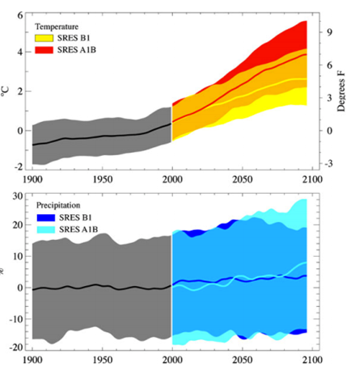

Fig. 4 Projected temperature (top) and precipitation (bottom) for the twentieth and twenty-first century model simulations for the Pacific Northwest, relative to the 1970–1999 mean. The top and bottom bounds of the shaded area are the 5th and 95th percentiles of the annualvalues (in a running 10-year window) from the approximately 20 simulations (Mote et al. 2010). The shaded regions represent the large uncertainties involved.

Other Factors: Hydroelectric power on the Columbia

There are a number of other factors that will affect Hydroelectricity on the Columbia River that are difficult or even near impossible to predict. Predicting the effects on hydroelectricity requires us to look at two distinct areas of impact: power production and power demand. Power production involves factors like water levels, stream flow, droughts, and other natural factors. Power demand relies on human factors that are harder to predict due to the less predictable nature of human life.

Defining Power Demand

When trying to estimate the power demand for a region, it is important to understand how each statistic is formed and what factors affect it. Power demand is a complex statistic based on population, temperature, economic power, and much more. According to Hamlet, et al., demand is determined by an estimated energy consumption per household, which is calculated by the number of days heating or cooling is required, multiplied by the number of people in a given area that have access to a heating or cooling unit (Hamlet, et al. 2010)[108]. So, the following equations can be used to discover the number of Cooling Degree Days (CDD) and Heating Degree Days (HDD). CEDI corresponds to Cooling Degree Days and stands for “Cooling Energy Demand Index” and HDD stands for “Heating Energy Demand Index” (Hamlet, et al. 2010) [108].

CEDI=(A/C_Pen)x(population)x(Annual Cooling Days)

where A/C_Pen is the percent of people who have access to cooling devices. This variable is set to have a minimum value of .08%

HEDI=(population)x(Annual Heating Days)

where the percent of people who have access to heating devices is assumed to be 100%.

Defining Population Projections

According to (Hamlet, et al. 2010) [page 110], population statistics are available through the next two decades from several sources. The most detailed and accurate of these for Washington State was prepared for the Washington State Growth Management Act (GMA) of 2008, which predicts population through 2030. The Hamlet article combined this with data from the high resolution Gridded Population of the World, version 3 statistics from CIESIN (Hamlet, et al. 2010) [110]. The article does however note that population trends are extremely difficult to predict even within this decade, and that anything past 2 decades is extremely uncertain.
There are many factors that play into population growth and decline in an area, which can involve human factors, such as job availability, birth rate/death rate, and cost of living, or natural factors, such as temperature rise making crops unable to grow, lack of snow pack creating yearly floods and droughts, and water levels dropping creating a river unsuitable for economic activity. Despite the many challenges in predicting an accurate population estimate, in order to determine the demand for power, one must determine the population.

Irrigation for Agriculture

Water used for irrigation detracts from water able to be used for hydropower. The area surrounding the Columbia River has most of Washington State’s farm land. When the land was originally settled, farmers had a hard time surviving because of the arid climate and dusty soil. Irrigation changed all of that. By pulling water from the Columbia River and natural aquifers (which are filled by the same snow melt as the Columbia River), farmers can now produce an abundance of crops in Eastern Washington. However, as water levels drop, less water will be able to be taken from the river without detrimentally effecting the power production of the Columbia Dam System; therefore, as the availability of water for irrigation decreases, so will the ability of farmers to sustain themselves in the summer with dry heat that kills crops. Factors like these are unreliable at best. How water will be portioned between power and food production relies entirely on our political and bureaucratic system.
The first settlers came to Washington State in the early1800’s; however, the area east of the Cascades remained virtually empty until the early to mid-1990’s. It wasn’t until the New Deal created irrigation trenches that this became common practice in Eastern Washington (Bureau of Reclamation, 2009). Today, according to Northwest Council, some 7.3 million acres of land are able to produce crops solely due to irrigation. In fact, “nearly all of the potatoes, sugar beets, hops, fruit, vegetables, and mint grown in the Columbia River Basin are irrigated, as are large crops of hay and grain. (NWcouncil.org, 2012)”
The production of electricity relies heavily on stream flow to move the large turbines found inside of a dam. When water is removed for irrigation, it reduces the amount of electricity produced by all dams downstream of the irrigation pumps. Northwest Council estimates that some 14.4 million acre feet of water is removed from the Columbia each year (nwcouncil.org, 2012). This amounts to approximately 274 million dollars every year (nwcouncil.org, 2012). As stream flow becomes increasingly erratic with reductions in snow pack, the ability to irrigate farmland and produce electricity will be much more difficult. The future of regulation regarding irrigation will have profound impacts on both farmers’ ability to support themselves in the Columbia River Basin and the dams’ ability to provide energy for large portions of the PNW and California. There is sadly no way to predict what changes in regulations might look like, so this remains a wild card in predicting the future of hydroelectric power in the Columbia River Basin.

Conclusion: 1 page

Climate Change has been a looming issue for over a decade across every continent on this planet. Many organizations, government agencies, and supranational bodies have dedicated time and money to exploring the possible impacts that climate change may have on our lives in the future. The variation in what those effects may be ranges from power production to food production to temperature, but each factor is interdependent with all the others. This report has looked at papers from the world’s leading scientists on climate change to discover the impacts that that change will have on this state’s ability to produce electricity, a resource that is taken for granted and yet is irreplaceable.

The Columbia River Basin provides 70% of all electricity used in Washington State through hydroelectric dams. Hydroelectricity production is highly dependent on stream flow for production, and stream flow, both in rate and timing, is in turn highly dependent on precipitation and temperature. This relationship is extremely complex, so models that attempt to predict the future only guesses based on past data, and cannot say with absolute certainty what the outcome will be. Due to the fact that these climate models do no predict the future with perfect confidence, there is much room for people to debate what actions must be taken to handle or mitigate these future changes. This paper wants to address that issue by showing the general trend of future predictions to show that despite the fact that it is unknown what will happen, an educated guess can be made of what is likely to happen. The hope is that this information will inform people about the approximate future to inspire action and decisions to support healthy steps towards a survivable future.

The models used in this paper follow a range of predictions, some with little change, some with a medium amount of change, and some with dire outlooks on the future. Since this paper has taken into account a variety of climate projections, people will see that in both the best and the worst case scenarios temperatures look to be moving in a certain way. In all of the noted climate models, the Pacific Northwest climate is projected to see a rise in both temperature and precipitation. It would be easy to assume that an increase in precipitation would mitigate the effects of temperature increase; however, projections show that every 1°C increase in temperature requires an approximately 3% increase in precipitation to maintain current levels of hydropower generation. This is not projected to occur in any of the climate models used in this paper. People must understand the actual impact of climate change, not as some obscure problem that may kill panda bears in a far off land, but rather as a future that will negatively impact every citizen of this state. Climate change will transform the daily lives of the people of Washington State, for better or worse, by depriving them of power, water, food production, and many other commodities that enable them to live the lifestyles that they do. The only way to change this fact is to mitigate and adapt to fit the projections seen in this paper.

Citations:

Bureau of Reclamation, 2012. The Story of the Columbia Basin Project-Washington. US Department of the Interior, Washington, DC. Available from http://www.usbr.gov/pn/project/columbia_index.html# (accessed on February 1st, 2012)

Elsner, M., Cuo, L., Voisin, N., Deems, J., Hamlet, A., Vano, J., Mickelson, K., Lee, S., Lettenmaier, D. 2010. Implications of 21st Century Climate Change for the Hydrology of Washington State. Climatic Change 102:225–260.

Hamlet, H., Lee, S., Mickelson, K., Elsner, M. 2010. Effects of projected climate change on energy supply and demand in the Pacific Northwest and Washington State. Climatic Change 102:103–128.

IPCC, 2007: Summary for Policymakers. In: Climate Change 2007: The Physical Science Basis. Contribution of Working Group I to the Fourth Assessment Report of the Intergovernmental Panel on Climate Change [Solomon, S., D. Qin, M. Manning, Z. Chen, M. Marquis, K.B. Averyt, M.Tignor and H.L. Miller (eds.)]. Cambridge University Press, Cambridge, United Kingdom and New York, NY, USA.

Lang, B. 2005. Columbia River. The Center for Columbia River History, Vancouver, WA. Available from http://www.ccrh.org/river/history.htm (accessed February 1st, 2012).

Markoff, M., Cullen, A. 2008. Impact of Climate Change on Pacific Northwest Hydropower. Climatic Change 87:451–469.

Miles, E., Snover, A., Hamlet, A., Callahan, B., Fluharty, D. 2000. Pacific Northwest Regional Assessment: the Impacts of Climate Variability and Climate Change on the Water Resources of the Columbia River Basin. Journal of the American Water Resources Association 36: 2.

Mote, P., Salathé Jr., E. 2010. Future Climate in the Pacific Northwest. Climatic Change 102:29–50.

Northwest Council, 2012. Columbia River History: Irrigation. Northwest Council, Portland, OR. Available from http://www.nwcouncil.org/history/Irrigation.asp (accessed on February 1st, 2012).

Salathé Jr., E., Leung, L., Qian, Y., Zhang, Y. 2010. Regional climate model projections
for the State of Washington. Climatic Change 102:51–75.

