Contents

Abstract 2

Introduction 3

The Project Statement 4

What is a Human-Powered Exercise Machine? 4

Goals of the Project 6

Project Timeline 8

Project Budget 9

5 Pricing Scenarios 9

Inverter Installation 10

Payment Agreement 10

Is the Price Worthwhile in the Long Term? 11

Machine Location 12

High Use Areas 12

Visibility 12

Room for Further Expansion 13

Accessibility and Safety 13

Ideal Location 14

Partners 16

The Campus Sustainability Fund 16

The Intramural Activities Center 17

SportsArt America 17

UW Campus Engineers 17

Contact Information of Project Partners 17

Process Moving Forward 18

CSF Application 19

Letter of Intent 19

Application 19

Literature Review 20

Methodology 21

## Abstract

I have always been interested in Sustainability, and as a CEP student, my focus has been researching what motivates people to action on environmental issues. I began thinking about power production and everyday activity, and found that almost every person in the United States works out a least once a week. That is an amazing amount of human-power going unharnessed. With the help of the Campus Sustainability Fund (CSF), the Intramural Activities Center (IMA), and SportsArt America, a local retailer of human powered gym equipment, I began the process of installing human powered gym equipment into the IMA Gym on our campus.

Working in direct contact with those three entities, I have gone through the process of rallying administrative support, working through funding agreements, and writing a full report for the CSF so that they can fund and install this project next year. This experience has shown me that when you dream big, anything can happen. I look forward to seeing the installation up and running at the IMA Gym by early September of 2014.

## Introduction

Environmentally friendly power production is a hot topic these days with Global Warming and Climate Change being big topics on the political scene. But, even with all this talk on methods of power production, every day people are disconnected from the reality of the situation. A number of entrepreneurial companies have come on the scene in the last 5-10 years, working with universities and gyms across the nation to provide a connection between everyday people and power production to educate and alleviate is understandings about what green energy and conservation really means.

These companies, including ReRev, the GreenRevolution, and SportsArt America, are installing power generators on gym equipment to allow people to take an active role in their cities’ power production. An added benefit of these projects is that it educates consumers on what their power use really means. Each green machine produces the power needed to run itself in addition to putting a small amount of power back into the grid.

My project, initially, was to work with the Intramural Activities Center at the University of Washington to get these machines installed by the end of the 2012-2013 school year. The idea was that the Campus Sustainability Fund (CSF), a student run fund that provides money to student designed campus sustainability projects, would partner with the IMA to make this project financially feasible for both parties. Due to a number of setbacks, that goal was not possible for this school year, so instead, I have produced a guide to the installation process for the CSF to use next year in an attempt to get this project installed. The following document is a report that explains what process needs to be followed to get these installed, what setbacks we have faced, and how we can move forward to get this project installed. The CSF has agreed to share this document with future students who are looking for projects so that someone can carry my work forward in a future year.

## The Project Statement

The University of Washington (UW) has pledged to be Carbon Neutral by 2050, and is taking steps to educate its students on both how to be sustainable and why it is important to be sustainable. As part of this ongoing mission, the UW has formed a number of action teams that support campus projects to engage and educate students. These include “Green Teams”, which work within each department to encourage sustainability actions, and the Campus Sustainability Fund, which provides money to innovative, student led sustainability projects.

With the help of the IMA Green Team and the CSF, I have worked for the last year to start the process of installing human-powered exercise machines. With the IMA’s director retiring at the end of this school year, it is not feasible to complete this project in this funding cycle. This manual, therefore, has been put together with the collaboration of the IMA and CSF to support students in future years in going through this project.

The CSF has agreed to work next year to find a student or group of students to complete this project, hopefully before the end of the 2015 school year. A copy of this manual will be distributed to all of the involved parties: the IMA, the CSF, our SportsArt America representative, and the Campus Engineers.

### What is a Human-Powered Exercise Machine?

A Human-Powered Exercise Machine is a variation on a typical exercise machine like an elliptical or a stationary bike. There are a number of companies that make these, including ReRev, Green Revolution, and SportsArt America. There are two types: {[[Power Free]]*what’s it really called? Look up on SportsArt website} and Power Generating. The former exists separate from the power grid, meaning that it does not require any power to run. These machines have been around for quite some time, including stair steppers that were popular in the 80’s and resistance bikes from the 90’s.

Power Generating Human-Powered Exercise Machines not only exist free from the grid, using the electricity from your workout to power the machine, but they also harness the excess energy and put it back into the power grid. This has a number of benefits, from the moral benefit of knowing that you are offsetting your carbon footprint, to the monetary benefit of lowering your utility bill. Different types of machines creating different amounts of power depending on the amount of power required to run the machine, but most machines also operate on a range, based on how the user sets the resistance of their workout. For instance, if you exercise on a level 5 resistance, you will be creating more energy than if you exercise on level 1.

Most people assume that these machines must be cumbersome and odd looking, or else why wouldn’t everyone have them. In fact, newer machines look virtually identical to traditional exercise machinery. In the photo below, you will notice that the only major difference is the presence of a small generator at the front or back of the machine.

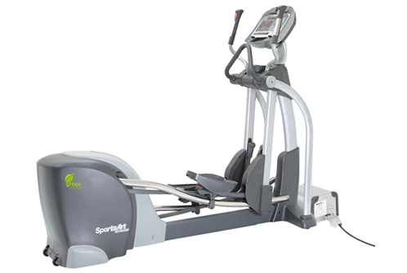

Figure 1: A power generating elliptical machine

As the technology improves the differences are lessening, but the biggest difference by far is the necessity of an inverter. An inverter converts the power from DC (what a battery uses) to AC (what the socket on your wall uses). A single inverter can convert electricity for up to 10 machines, but is a large expense compared to buying a single piece of exercise equipment. As it currently stands, due to the necessity of the inverter, this type of installation is much too expensive for single households to afford, and thus these machines are mostly only available to commercial buyers.

There are a few different ways to purchase these machines. A company can either purchase new machinery prefabricated for energy production, or they can take existing machinery and retrofit it with a generator and inverter to make it into a power generating machine. In the section below, titled “Why SportsArt America”, we will discuss why a prefabricated machine is often the better answer.

#### Why SportsArt America?

After an initial conversation with the IMA in which they expressed that they were at maximum capacity for equipment, and currently had no need to replace equipment, we were looking into retrofitting the existing machines at the IMA into power generating machines. There are a number of companies that can do this, but the top rated companies were ReRev and GreenRevolution, both of which focused solely on stationary bikes. We began conversations with both companies to hear more about their products, received a list of all the universities and companies that each had worked with and a list of all the machines each company was able to retrofit, and began exploring our opportunities based on that information.

After Katie Beth, the IMA Green Team Director, spoke with Precor, a major exercise equipment distributor, and producer of the only type of equipment that the IMA owned that either ReRev or GreenRevolution would be able to retrofit, it became apparent that Precor was not onboard with retrofitting these machines. Each machine comes with a warranty, but Precor stated that retrofitting these machines would void all warranties, and there was no way around that.

A number of Universities had worked with these companies before, and several of those had retrofitted Precor equipment, so we began to question the underlying truth of the statement. A University is unlikely to pay money to have a retrofit done if it voids the warranty on all of the machines. Thus, what changed in this situation? Why would Precor change their policy on voiding warranties regarding these retrofits?

After contacting several Universities, Katie found that the machines did not respond well to the retrofit. They would do fine for a year or two, and then rapidly deteriorate. The installation of the generator did not interact well with the original machinery, and thus Precor was forced to discontinue its practice of allowing these retrofits to happen without penalty.

Using this information, we had to broaden our search to find a retailer that sells these machines prefabricated to generate power. In our search we came across a number of companies, but one in particular, SportsArt America, is actually a local company, based in Everett. They had been reaching out to the UW for years trying to build a relationship, and this could very well be their chance. Katie reached out to them and scheduled a meeting between myself and Dan Leary, their head sales rep.

In meeting with Dan, I discovered that their line of power generating equipment was exactly what we were looking for. Not only was it a large selection, including ellipticals, stair steppers, and recumbent bikes, but because we are their local University, they were willing to discount the price for us. With this discount, the machines we are considering purchasing are only slightly more expensive than normal machines, and they pay themselves back through power production.

### Goals of the Project

The project has 4 main goals, each of which will be achieved through use of the installed machinery. Our main partners in the project, the CSF and IMA, are also dedicated to these tenants, which make them strong collaborators in this process. For more detail, see the section on Partners. The 4 core goals of the project are:

Education

Sustainability

Student Engagement

Cutting Costs to the IMA

#### Education

These machines will educate students on power production and power consumption by giving them a way to understand difficulties of power production in relatable terms. Instead of an academic lecture on the dangers of over consumption, these machines will tell students after every workout how much electricity they have produced in terms of everyday appliances. For instance, after a 30 minute workout, the machine may read: “You’ve produce enough electricity to run a light bulb for 3 hours!” This way of understanding power production makes the issues of overconsumption much more tangible than speaking in the scientific terms of watts or in the overgeneralized terms of social sciences.

[[write more about what other schools have seen or what students have said?]]

#### Sustainability

These machines not only contribute power to the grid, but also take power intensive machinery off of the grid. On average each machine produces approximately $250.00 of electricity per year. The IMA was unable to provide statistics on the current average power usage per machine, so we were unable to pull statistics on how much power this would save.

The UW is looking to be carbon neutral by 2050, and is trying to cut its power usage substantially by 2020. The IMA is the 2nd biggest power consumer on the UW campus, following only after the Triangle Garage, so minimizing the power footprint of the IMA will make a large impact in terms of that goal.

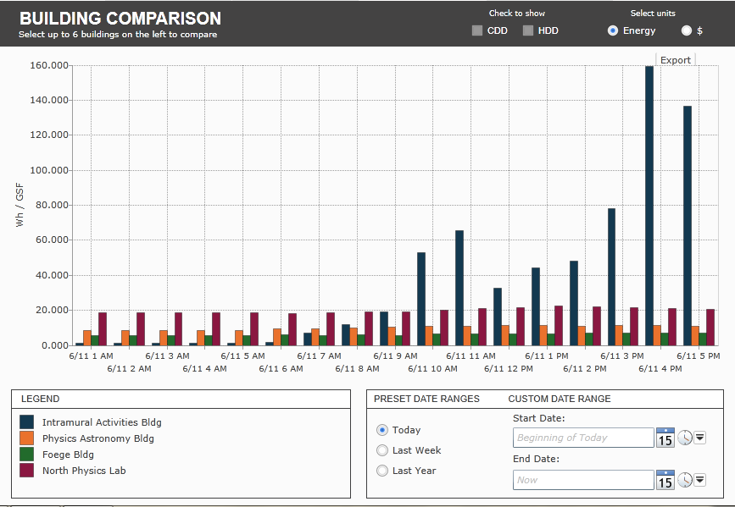

Figure 2: The IMA is seen here in blue, compared with the 3 next biggest power consumers on campus. At peak usage, the IMA is drawing more than 7 times the amount of power as the next runner up.

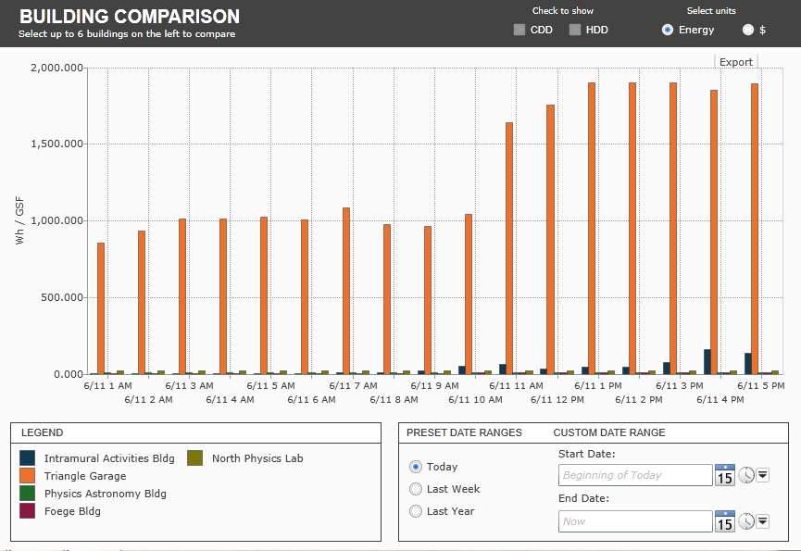

Figure 3: The Triangle Garage is the only building on campus with a higher power draw than that of the IMA. The IMA is the only building that even registers on this graph compared to the Triangle Garage.

#### Student Engagement

One of the biggest tenants of both the CSF and the IMA is increasing student engagement. It is important for a number of reasons, but namely because engaged students are more likely to learn, more likely to make change, and more likely to give back to the community at large. These machines operate off of student engagement, quite literally. All of the benefit, from education to sustainability, to cutting costs, comes directly from students engaging with these machines and taking the time to use them throughout their college careers.

The ideal of these machines is that through engagement of students in a normal day activity, we can make them feel good about themselves by giving them an easy alternative to power consumption that actually gives back to the larger community. While they are giving back, they are also learning about what power consumption means, and how hard production really is. Thus, it is only through engagement that this project succeeds.

#### Cutting Costs to the IMA

Of course this is always important to the IMA. It is not by any means a goal of the project or a goal of the CSF, but certainly is a happy byproduct. It is important to mention in this section, because it is a big part of why the IMA is interested in this project. Not only does it increase sustainability, which is good PR for their department, and engage students, which increases frequency of visits and likelihood of visits to the IMA, but it also will cut their baseline costs by providing them with a form of income. The IMA generally has no interest in income as they are funded by the UW and student fees for specific activities, but the fact that these machines will pay for themselves makes it much more feasible to look at these as a long term investment. Once the machines are paid off, which with the help of the CSF is less than 9 years, the remaining years of use (generally anywhere between 1-6 years), the IMA will be making money to offset their costs to maintain and run the gym. This will help them to expand existing programs, allot more money to the Green Team, and fund any additional machinery or projects they may be interested in, including potentially investing in more human powered machinery.

## Partners

In order to complete this project, the student running it will need to work with four important groups. They will likely reach out to other groups for supplementary information, but these four groups should be able to help them work through the majority of the steps needed to complete the project. I have already worked with these groups for the last 5-9 months, and all of them have been provided with a copy of this manual. I have also informed them that another student will be taking over this project, but that this manual hopes to provide enough explanation and context to allow the student to move forward without repeating any work.

The four groups are as follows:

* Campus Sustainability Fund
* Intramural Activities Center Green Team
* SportsArt America
* Campus Engineers

Below I will explain the importance of each group and their role within the project.

### The Campus Sustainability Fund

The Campus Sustainability Fund (CSF) is a student-led organization that funds student projects involving education, sustainability, and engagement. Each year they award between $100,000 and $500,000 in grants. They assist students throughout the process by assisting them in finding appropriate departments and contacts for their projects, helping them articulate and write proposals and applications for the CSF award process, and assisting them with anything else they can.

Throughout my process, I have been lucky to work with Adam Falhstrom and Kyle Murphy, both of whom will be ending their jobs with the CSF at the end of this year. They will leave files and information for their successors about this project, along with this manual, to ensure that there is remaining institutional knowledge for the student that continues this process.

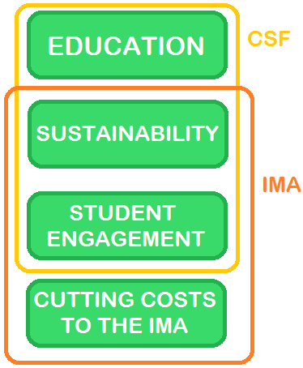The CSF was a logical choice for a partner in this project because they are interested in 3 of the key tenants of this project.

Figure : The IMA and CSF are strong partners for this project because, as the graphic shows, their values and goals align almost entirely with the goals of this project.

### The Intramural Activities Center

The IMA is the University of Washington’s Intramural Activities Center, and it focuses on connecting students to physical activity. To fulfill its goal, the IMA hosts a wide range of exercise opportunities in its facility including a swimming pool, running track, tennis courts, rocking climbing gym, exercise and weight rooms, and so much more. However, as the UW works towards a goal of 2050 carbon neutrality, the IMA has a conflicting responsibility: to cut its power usage. Almost every activity it provides requires some form of electricity, whether from machinery, safety checks, lighting, or heat, the IMA is the 2nd largest power user on Campus (see figures 2 and 3 for more detail).

As seen in Figure 4, the goals of the IMA, and the CSF align almost entirely with those of this project. This makes it easy for all parties to come together and pool resources to complete the project.

### SportsArt America

Initially, the IMA and I were looking into other companies to retrofit old machinery or purchase new machinery. However, SportsArt America is a local company, which means supporting our local economy. They have been trying for years to work with the UW, because we are their home university. As such, they are willing to offer us discounted pricing compared to what other companies would offer, that makes these machines comparable in price to a traditional piece of machinery.

### UW Campus Engineers

The UW Campus Engineers are a part of every UW project involving electricity. They ensure that all the work supports the UW’s goal of energy efficiency, that all work is done by licensed, bonded contractors, and ensure that fair pricing is being provided. The UW Campus Engineers are aware of this project, but have not been approached about contacting an electrician to do the installation. That process will take anywhere from 2 weeks to 3 months.

### Contact Information of Project Partners

IMA: Katie Beth [Kbeth6@uw.edu](mailto:Kbeth6@uw.edu)

CSF Coordinator: [uwcsf@uw.edu](mailto:uwcsf@uw.edu)

SportsArt America: Dan O’Leary [dan@sportsartamerica.com](mailto:dan@sportsartamerica.com)

Campus Engineers Electrician’s Line: 206-685-1411

### Project Timeline

1. Approach CSF and IMA September
2. Approve Contractors for Installation October
3. Apply to CSF November
4. Approval by CSF February
5. Sign contract with contractors, CSF, IMA, and vendors March
6. Receive funds from CSF and IMA and distribute to contractors and vendors April
7. IMA preps for installation June/July
8. Contractors install inverter and all required power conduit July/August
9. Project is completed September

## Project Budget

The budget is dependent on a number of factors, mostly to do with our machine choices. So, the following questions were discussed to create the four scenarios that follow:

Which type of machines will see the most use?

What types of machine does the IMA currently need?

What are the trends for machine usage?

What is the cost per machine?

The results for these questions show that the elliptical and the upright stationary bike are the most logical options to purchase at this time. The IMA is trying to replace 6-15 upright stationary bikes at the end of this 2 year funding cycle; the elliptical is currently the most used piece of equipment in the gym, and although none need to be replaced currently, if the IMA is optimizing the human generating power installation for student usage, ellipticals will be a key part of it. If trends continue as they are, the elliptical will remain popular for a long time hence, as they have been growing in frequency of use for the last 2 years.

In working with SportsArt America, a local gym equipment retailer, we were able to secure discounted prices through their company compared to other companies selling similar machinery. They have wanted to get into the UW IMA for several years, and are excited about the opportunity to showcase their Green Machines at their local University. The prices shown below are only slightly higher than what the IMA pays for standard (non-generating) exercise equipment. The discounted prices are as follows:

Elliptical (G862-front generator) $4,475.00

Elliptical (G872-rear generator) $4,325.00

Upright Bicycle $2,395.00

Recumbent Bicycle $2,885.00

As shown above, the ellipticals are substantially more expensive than the stationary bicycles,

Below I have provided the 4 recommended scenarios for purchasing, including the prices for installation of everything except for the inverter.

### 5 Pricing Scenarios



### Inverter Installation

The inverter needs to be installed by a licensed electrician. SportsArt America will not be able to provide these services, so a contractor needs to be found through the Campus Engineers. They approve contractors for use by UW Agencies and Offices, and ensure that said contractors meet the standard of excellence expected in all UW projects. They also make sure that prices are standardized and fair, and ensure that all projects are completed in a professional and long lasting manor. Because the IMA was unable to sign off on this project until a new Director has been chosen, we have as of yet been unable to secure a quote for the services of installing an inverter.

In order to install the inverter, the chosen electrician will need to know:

* The technical specs of the inverter being installed
* The location of the machinery in order to run conduit to each machine
* The voltage and wattage running through the circuitry in the wall to determine if the wiring needs to be upgraded for the installation

Katie Beth and I spoke briefly about these questions, and found that the specs can be easily retrieved from Dan Leary, our SportsArt contact. The voltage specs will need to be retrieved from the Campus Engineers, who can get that information when approached about identifying a contractor.

### Payment Agreement

The CSF and IMA have discussed splitting the cost of the project between the two of them equally. Each of them would handle the following:

CSF:

* 50% of the cost

IMA:

* 50% of the cost
* The labor required to move and return older machines to make space for the installation process

The cost would be between $27,750.00 and $36,725.00, not including the installation of the inverter. If we add $10,000, which should be more than enough money to install the inverter, the overall cost ranges from $37,750.00 to $46,725.00.

This means that the IMA would pay between $18,875.00 and $23,362.50, not including the labor they would pay either way to remove old machines and reposition the new machines in the new location.

### Is the Price Worthwhile in the Long Term?

When we do out the math on the price of this investment, we find that the installation would pay itself off in 9 years. That means that each machine would have 1-6 years to put power into the grid and give back to the IMA community.

The CSF has no investment in the money earned from the project; they are interested in the success of student engagement and education, and the hope that the IMA will continue to invest in more human powered machinery.

The IMA on the other hand, is very concerned with the long term costs of the installation. The fact that the machines will be able to turn a small profit (approximately $2,500.00 per year) is a huge selling point with the IMA.

The math works out to be:

$37,750.00 to $46,725.00 initial investment

divided by 2 (the CSF will be paying for half)

equals $18,875.00 to $23,362.50

Subtract

[$250.00 * 10 (number of machines)]* 10 to 15 years

for the profit of the machines

equals a profit for the IMA of

$6,125.00 to $14,137.50

The cost to maintain the equipment is approximately the same as a traditional piece of equipment, so the IMA’s investment would in the end have a much higher return on investment than a traditional piece of equipment.

## Machine Location

By way of placement, there are three logical areas that would be preferable for the IMA:

* The South wall window bay of the 1st Floor Machine Room (Fig. 1)
* The West wall window bay of the 1st Floor Machine Room (Fig. 2)
* The 3rd Floor Machine Bay on the NE corner of the running track (Fig. 3)

Similarly to the decision making process on deciding how many of which machines to order, the process of deciding where to place the machines is heavily subjective, requiring the decision makers to balance a number of factors:

* What will see the highest use?
* What has the highest visibility?
* Where leaves room for further expansion later?
* Where has the best accessibility and safety for conduit placement?

### High Use Areas

The highest use area is debatable. The IMA tried to locate statistics to determine the highest machine usage within the gym, but the statistics are not well organized and are difficult to wade through. Each piece of machinery logs how many hours it has been used per day, and total. The maintenance staff uses these records to prioritize replacement and repairs, but it is not categorized by section, rather by usage. The system has not been formatted to pull information in this way, so the IMA has had difficulty identifying what the highest usage location in the gym is. There are a number of factors that impact students’ preferances including, but not limited to:

* Visibility (to outsiders) of themselves while exercising
* View out the window
* Ability to view television
* Juxtaposition to other people while working out
* Type of machinery
* And many more

As we were discussing location, we put this as a second tier priority after the other questions regarding location choice.

### Visibility

Visibility is important because it ensures that students are aware of the installment, thus increasing the usage of the machines. The more use these machines get, the more cost effective they become, as they are paying themselves off with every watt produced. In addition, the machines are a great PR opportunity for the UW and the IMA, as this will be the first installation in Western Washington. Visibility is increased through two main factors:

* Being in a high usage area
* Being in an area where passerby can see it

The area best suited for visibility is the South wall window bay of the 1st Floor Machine Room, because it can be viewed internally by anyone using the exercise machines and all students entering or exiting the IMA. These are the main target audiences: exercise machine users and IMA users.

The next most visible area is the West wall window bay of the 1st Floor Machine Room, because most people entering the exercise machine room will see it, most people entering the Rock Climbing area will see it, and most people parking in the parking lot directly in front of the IMA will see it.

The least visible area is the 3rd Floor Machine Bay on the NE corner of the running track. This area is only visible to students who are using the running track. The area is on the opposite side of the running track from the entrance, so by the time students see it they are already part way through their exercise routine, and thus less likely to choose to try the machines in that visit.

### Room for Further Expansion

The inverter will have space for 10 machines, which means that we need to have space for expansion in 2 of the scenarios . As such, it is important that the space we chose has space to fit up to 10 machines. All three of the suggested locations have space for 10 machines, but some more easily than others. The two 1st Floor locations would have room for 10 machines, plus room for additional machines, should the IMA decide to expand the program in future years. The 3rd Floor Machine Bay has space for all 10 machines, but the space is limited by way of future expansion. Only about 25 machines fit in the 3rd Floor Machine Bay.

### Accessibility and Safety

It is very important that the space is safe for students. One the biggest issues the IMA faces with machine placement is making sure that the cords and conduit used to plug the machines into the wall is not running across an area where it will cause people to trip. With the inverter, this problem is exacerbated because the cords will not be pulling power, but rather creating power. It could cause fire hazards in addition to tripping hazards, should the cords and conduit be in the walkway. As such, it is very important that all 10 machines be able to fit into one row, or, that the contractor be able to run the conduit under the floor, to reduce tripping and fire hazards.

In the South and West wall window bays of the 1st Floor Machine Room, this should not cause any problems. With the machinery against the window, the conduit can run parallel to the window in an area where no one is walking. Currently all of the power cables are run under the floor, but that space is full, so if the machines were placed anywhere but in the window bays, the cost of the project would rise significantly. The contractor would need to raise the floor to allow space for additional under floor space to allow for the conduit and cords for the inverter.

In the 3rd Floor Machine Bay on the NE corner of the running track, the machines would sit directly in front of the railing that separates the running track from the machine bay. This area cannot fit all 10 machines in one row, so the contractor would likely need to pull up the floor to create space to run conduit and wires for the inverter. Again, this would significantly raise the costs of the project.

### Ideal Location

Given the above four explanations of space preference, we decided that the locations are preferable in the following order:

1. The South wall window bay of the 1st Floor Machine Room
2. The West wall window bay of the 1st Floor Machine Room
3. The 3rd Floor Machine Bay on the NE corner of the running track

The South Wall is the best location because:

* It has the highest visibility of the three areas
* It would be easy to expand along the South wall
* It is the most easily accessible of the three locations, while still being safe to run conduit and cables to the machines
* Usage wise, it is definitely higher usage than the 3rd floor, but no claim can be made about this area in comparison to the West wall

The West Wall is the second best location because:

* It has the second highest visibility of the three areas
* It would be easy to expand along the West wall
* It is still easily accessible, although slightly less so than the South wall, while still being safe to run conduit and cables to the machines
* Usage wise, like the South wall, it is higher usage than the 3rd floor, although little claim can be made as to which of the 1st Floor locations has higher usage statistics

The 3rd Floor Machine Bay is the least favorable location because:

* It has the lowest visibility of all three areas, with almost no one being able to see it unless they are on the 3rd floor for another reason
* It would be difficult to expand due to the design of the area without compromising safety or cost
* It is not very accessible, as it can only be accessed via the running track, and is less safe than the other areas because if all 10 machines were installed, they would need to be separated into multiple rows
* The usage of this area is distinctly lower than the 1st Floor, even without statistics, we can safely make that claim. Many students do not even know that there is a machine bay on the 3rd Floor

In light of this information, it is our firmly held belief that the best return on investment would come from placing the machines along the South wall window bay of the 1st Floor Machine Room. It has the best combination of factors working towards its success. This decision cannot be finalized without the approval of the IMA, and the final decision does rest within their hands, although the CSF does hold some leverage as they will be funding half of the project.

Regardless of the decision of the IMA, based on these factors, it is our opinion that the 3rd Floor Machine Bay on the NE corner of the running track does not make sense, and it would be a better use of time and energy to wait for the IMA to agree on one of the other two locations rather than invest money in a subpar location.

## Process Moving Forward

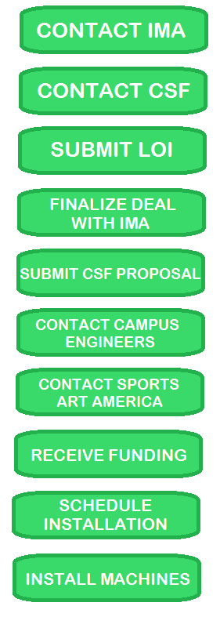 The process moving forward is outlined in Figure 5, to the left. All of these steps have already been started, and all the incoming student needs to do is collect the documents contained within this packet, and discuss them with the IMA and CSF. The IMA agreement has been outlined above in the section discussing costs, and the CSF process is outlined below.

## CSF Application

The CSF accepts applications twice a year. The dates for submittal can be found on their website: <http://f2.washington.edu/oess/csf/> The first round of applications usually requires a Letter of Intent to be submitted around the end of Fall quarter, and a formal application around the beginning of February.

While there is a second application period in April and May, the first period is less competitive, and leaves more time to set up the installation to occur over summer quarter than waiting until the second round of applications.

The application happens in several different steps. The first step is the Letter of Intent, in which a student submits a formal letter giving an overview of the project, the costs involved, and a general timeline. This is a great opportunity for feedback from the CSF, which can be used to strengthen the actual application.

Figure : A graphic exlaining the process that needs to be taken by the next student involved in this process.

The second round of the application process is submitting a formal application. This involves an overview of the project, including a formal and finalized budget, a list of contacts and partners, a breakdown of stakeholders and who will be providing what, and what benefits the final product will hold in relation to the CSF’s 4 main components: Environmental Impact; Student Leadership & Involvement; Education, Outreach, & Behavior Change; Feasibility, Accountability, & Sustainability. The CSF goes into detail about each of these ideals on their website, and the CSF project contact is always happy to assist in phrasing these ideals for this project.

Figure : An explanation (taken from teh CSF's website) of how the CSF application process works.

## Literature Review

UW Building Energy Statistics:

<http://dashboard.mckinstry.com/uw/>

## Methodology

Every project requires a process. While some projects are heavily academic and require a lot of intensive research through books and scholarly articles, this project was much more of a hands on process. Much of the methodology was completed through interviews, emails, and speaking to representatives from other schools. One of the biggest challenges that I ran into is that every University has a different infrastructure-rarely do you find two with the same titles or contacts for projects such as these. Thus, a lot of my project involved navigating the complicated bureaucratic channels of the UW to find the contacts necessary to approve the project. Below I will lay out the backbone of my methodology in an outline format, so that you can understand the process that I went through to understand the steps this project requires.

1. Reach out to the IMA
2. Get their approval to reach out to ReRev
3. Speak with IMA about the opportunity with ReRev
4. Have a meeting with both parties present and then hear feedback from the IMA on the opportunity
5. Work with the IMA to find other possible companies to ensure we are following the most effective and beneficial path
6. Contact each company to compare prices, opportunities, and find out who else they have worked with
7. Find out impact of retrofitting machinery versus purchasing new machinery by contacting warranty companies for existing machinery
8. Contact other Universities and gyms to find out more about their experience with each company
9. Meet with the IMA to report feedback and hear what they have found
10. Narrow down the list of possible companies to the company that seems most viable based on the information gathered
11. Meet with the IMA to discuss possibilities with the chosen company
12. Have IMA reach out to that company and give them clearance to discuss financial details with me
13. Meet with company representative to discuss opportunities and costs
14. Meet with IMA to discuss conversation with company representative; discuss what to do moving forward
15. Meet with CSF to discuss financing possibilities
16. Submit Letter of Intent (LOI) to CSF
17. Receive feedback from CSF on LOI, incorporate feedback
18. Meet with IMA to discuss number of machines and where to install
19. Create budget document
20. Bring budget document to both CSF and IMA
21. Discuss with each group and get approval to move forward
22. Contact company we decide to work with (SportsArt) and talk about installation costs
23. Incorporate installation costs into budget
24. Meet with IMA to discuss issues with installation: who will move machinery, how to balance getting rid of old machinery with buying new machinery, find out about costs of inverter installation
25. Have IMA reach out to Campus Engineers and begin finding licensed electrician to do installation.
26. Take project to IMA Director to get final approval to move forward before we sign agreement with Campus Engineers

This is where our project stalled: We could not get approval from the director, as he did not want to sign on to a project that would not be completed before he retired.

1. Meet with CSF to determine if project would be possible for another student to take on next year
2. Meet with SportsArt America representative to discuss possibility of continuing project next year
3. Discuss future possibilities with the IMA
4. Begin writing a manual to explain process to another student next year
5. Provide a copy of the manual to each of the involved organizations to ensure that everyone is on the same page and the project can move forward without pause next yearAcknowledgements

There are a number of people I would not have been able to complete this project without, some who have been mentioned repeatedly throughout this manual, and others who worked entirely behind the scenes offering tips, suggestions, and support again and again through the year I was working on this project. I’d like to take a moment to thank them all for their support and give them credit for their part in making this project come true.

My academic advisors and support system:

Caitlin Dean, CEP Program Manager

Chris Cambell, CEP Director

Caitlin Budd, CEP accountability group

Allison Hamburg, CEP accountability group

Josh Cowgill, CEP accountability group

The friends that inspired me to look into this project and helped me move forward when I felt stuck:

Adam Falhstrom, CEP graduate and student contact in the Office of Sustainability and Stewardship

Sunni Wissmer, CEP student and Student Contact in the CSF

Archie Sherwood, Electrical Engineering student

Dan Weinkauf, Electrical Engineering student

The professional contacts who repeatedly helped me to find ways to succeed, even when things seemed impossible:

Katie Beth, IMA Green Team Director

Dan O’Leary, Western Sales Advisor for SportsArt America

Kyle Murphy, Student Liaison to the CSF at the Office of Sustainability and Stewardship

The many CEP students who helped encourage me, gave me critical feedback, and helped me to find solutions when I hit road blocks.

My family for inspiring me to be interested in sustainability, and always pushing me to look for logical and feasible solutions to everyday problems.

Without all of these people, this project would not have been possible. It goes to show underline the biggest lesson that CEP has taught me: even with planning and academic knowledge, community is necessary for every success.

Thank you!